AQF 621: Aquaculture Nutrition & Feed Technology

Acknowledgements

This course was authored by:
Dr Jeremiah Kang’ombe
Aquaculture Department
Bunda College of Agriculture
Email: Jeremiah_Kangombe@yahoo.com

The course was reviewed by:
Dr Nazael Madalla
Sokoine University of Agriculture
Email: nmadalla@googlemail.com

The following organisations have played an important role in facilitating the creation of this course:
- The Association of African Universities through funding from DFID (http://aau.org/)
- The Regional Universities Forum for Capacities in Agriculture, Kampala, Uganda (http://ruforum.org/)
- Bunda College of Agriculture, University of Malawi, Malawi (http://www.bunda.luanar.mw/)
These materials have been released under an open license: Creative Commons Attribution 3.0 Unported License (https://creativecommons.org/licenses/by/3.0/).
This means that we encourage you to copy, share and where necessary adapt the materials to suite local contexts. However, we do reserve the right that all copies and derivatives should acknowledge the original author.
COURSE OUTLINE

- PROGRAM : PhD in Aquaculture and Fisheries Science
- COURSE TITLE : Aquaculture Nutrition and Feed Technology
- COURSE CODE : AQF 621
- YEAR : One
- PRESENTED TO : Faculty of Environmental Sciences
- PRESENTED BY : Aquaculture and Fisheries Science Department
- LECTURE HOURS/WEEK: 2 x 1 hr (Semester 2)
- PRACTICALS/TUTORIAL/HOURS/WEEK: 1x 2 hr (Semester 2)

- METHOD OF ASSESSMENT: Course Work 40%
End of Course Exam 60%
- AIM(S) OF STUDY
To enhance students understanding of fish nutrition and its application in aquaculture for improved fish production

- COURSE OBJECTIVES

By the end of the course students should be able to:

- synthesize fish nutrition principles
- apply fish nutrition principles in aquaculture
- apply feed formulation procedures, nutrient analysis in fish and feeds
- conduct feeding trials.

- TOPICS OF STUDY

a) Nutritional energetics
i. Fate of food in fish
ii. Energy partitioning
iii. Bioenergetic model

b) Feeds and feed formulation
i. Available ingredients
ii. Restriction in feed formulation
iii. Tools used in feed formulation

c) Anti-nutritional factors
i. Types and their sources
ii) Analytical procedures
iii) Their effects on growth of fish

d) Larval diet enrichments
i. Larval diets used in aquaculture
ii. Rotifer enrichment
iii. Artemia enrichment
iv. Cladoceran enrichment
v. Copepod enrichment

- Digestibility assessment
i. Direct method
ii. Indirect method, markers used.
iii. Diet vs. individual ingredient digestibility assessment

- Nutrition deficiency
i) Signs of major nutritional deficiencies
ii) Protein, amino acids deficiency
iii) Fatty acid deficiency

- Unconventional feed sources
i. Potential use of pigeon peas, bambara nuts, common beans, velvet
beans, cow peas etc
ii. Use of sugar byproducts i.e. bargasse
iii. Use of industrial wastes of animal and plant origins.

- Supplementary and complete diets
i. Rationale of using supplementary diets
ii. Rationale of using complete diets

- Live feed production
i. Natural production
ii. Artificial production

j) Feed processing and manufacturing
- Types of feeds
- Forms of feeds
- Feed manufacturing machinery
- Manufacturing process
- Drying techniques
- Storage/Sampling procedures
- Fish Feed manufacturing in Malawi, SADC region and beyond
PRACTICAL TOPICS

  - Nutrient composition analysis of feed and fish tissue
  - Antinutritional factors analysis: Protease inhibitors, Phytates, Glucosinolates, Saponins, Tannins, Oligosaccharides, Phytoestrogens, Alkaloids, Antigenic compounds, Gossypols, Cyanogens, Momosine, Antivitamins, Aflatoxins
  - Feed formulation tools-Trial and Error, Pearson’s Square, Linear Programming (MIX-IT WIN)
  - Feeding and digestibility trials of various feeds
  - Culture of copepods, rotifers, artemia, cladocerans and phytoplanktons
  - Sampling and enumeration of live foods
  - Chlorophyll a, b and c analysis
  - Industry application-Visits to fish feed manufacturers

- PRESCRIBED TEXTS

De Silva, S. S. and Anderson, T.A. (1995). Fish Nutrition in Aquaculture, Chapman and Hall. London.

Lavens, P and Sorgeloos, P. (Eds.) (1996) Manual on the production and use of live food for aquaculture. FAO Fisheries Technical Paper 361. Food and Agriculture Organization of the United Nations, Rome.

Lovell, R.T. (Ed.) (1998) Nutrition and feeding of fish. Second Edition. Kluwer Academic Publishers, Massachusetts.

- RECOMMENDED READINGS

Agricultural Software Consultants, Inc. (1997). MIXIT-WIN. Feed Formulation for Windows 95 or NT. Virginia.

Bhujel, R. C.; Yakupitiyage, A.; Turner, W. A. and Little, D. C. (2001). Selection of a Commercial Feed for Nile Tilapia (Oreochromis niloticus) Broodfish Breeding in Hapa-in-Pond systems. Aquaculture 194: 303-314.
Brummett, R.E., (2000). Food organism availability and resource partitioning in organically or inorganically fertilized Tilapia rendalli ponds. Aquaculture, 183: 57-71.

Carpenter, K. J., (1960). The estimation of available lysine in animal protein. Biochemistry Journal 77: 604-610.

Coutteau, P., (1996). Microalgae, In: Lavens, P. and Sogeloos, P. (Eds.). Manual on the production and use of live food for aquaculture. FAO, Rome.

Delbare, D. and Dert, P., (1996). Cladocerans, nematodes and trochophora larvae, pp.283-295. In: Lavens, P. and Sogeloos, P. (Eds.). Mannual on the production and use of live food for aquaculture. FAO, Rome.

Delbare, D., Dert, P. and Lavens, P., (1996). Zooplankton, In: Lavens, P. and Sogeloos, P. (Eds.). Manual on the production and use of live food for aquaculture. FAO, Rome.

Dert, P., (1996). Rotifers, In: Lavens, P. and Sogeloos, P. (Eds.). Manual on the production and use of live food for aquaculture. FAO, Rome.

De Silva, S.S. and Davy, F.B., (1993). Fish nutrition research for semi-intensive culture systems in Asia. Asian Fisheries Society 5: 129-144.

El-Sayed, A.M., (1999). Alternative dietary protein sources for farmed tilapia, Oreochromiss spp. Aquaculture 179: 149-168.

El-Sayed, A.M., (2003). Effect of fermentation methods on the nutritive value of water hyacinth for Nile tilapia, Oreochromis niloticus (L.) fingerlings. Aquaculture 218: 471-478.

George F., H. P.S. Makkar and Klaus B. (2001) Antinutritional factors present in plant-derived alternate fish feed ingredients and their effects in fish. Aquaculture 199: 197–227

Hardy, R. W. (1999). Collaborative Opportunities between Fish nutrition and Other Disciplines in Aquaculture: An Overview. Aquaculture 177: 217-230.

National Research Council (NRC), (1993). Nutrient Requirements of Domestic Animals. Nutrient Requirements of warm water fishes and shell fishes. Revised Edition. National Academy Press, Washington DC, USA, 114 p.

Olvera-Novoa. M. A, Martinez-Palacios, c.a. and de león, e.r. (1994). Nutrition of fish and crustaceans a laboratory manual. Food and Agriculture Organization of the United Nations – FAO Mexico City.

Topic 1: Nutritional Energetics
Learning Outcomes

Learning Outcomes
- Synthesize the major applications of nutritional energetics in fish
- Explain different components of nutritional nergetics in fish
Key Terms
Digestion process in fish; Energy partitioning, Bioenergetic model

Introduction to Topic
A constant supply of energy is required by all animals to sustain life. The sources come from feed eaten, natural productivity, body stores (times of environmental stress or feed deprivation).It depends on how much energy is needed by aquatic organisms, how it varies from terrestrials, what are the sources, how is energy partitioned for various uses. The original energy source for food energy is the sun. Energy from the sun is converted by photosynthesis into the production of glucose. Glucose is the hydrocarbon source from which plants synthesize other organic compounds such as COH, protein, lipids. As previously mentioned, one must consider the quality of these sources as animals are not heat engines and they can’t use the multitude of sources of energy we have (e.g., flywheels, falling objects, the tide, etc.). Fish must obtain their energy from chemical bonds of complex molecules by oxidizing these bonds to lower energy states using oxygen from the air.

Sub Topics

  - Fate of food in fish

    - Categories of food digestion processes
There are a number of processes that feed undergoes in the body of fish. These include ingestion, digestion, absorption and elimination (Fig.1)
Fig1. Processing of feed in the body of fish

1.1.2 Fish digestion: ecological categories
- pelagic plankton feeders
- benthos/benthic feeders
- because each species occupies a niche in the environment, finfish polyculture mixes species from various divisions
- these considerations, in combination with phylogeny largely determine digestive morphology
- fish with similar feeding habits can show high level of variation in digestive apparati (Fig 2)
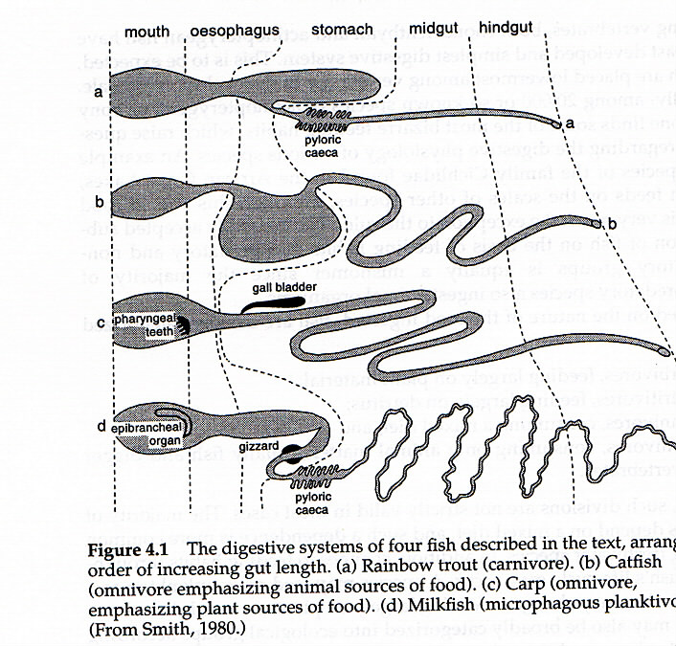
Fig 2. Digestive systems of different fish species

1.1.3 Fish Digestion: anatomy
- Two major groups: with stomach, without
- Those without stomach: cyprinids (carps)
- Those with stomach: cold-water salmonids, warm-water catfish, tilapia, eels, grouper
- Note: all “pure” predators have a stomach and teeth
- relative gut length (RGL): gut:body length
- high RGL = species consuming detritus, algae (high proportion of indigestible matter)

1.1.4 Relative Gut Length
Species | Feeding | RGL
Labeo horie | Algae, detritus | 15.5
Garra dembensis | Algae, inverts | 4.5
Barbus sharpei | Plants | 2.8-3.1
Chelethiops elongatus | Zooplankton | 0.7
Chela bacaila | Carnivorous | 0.9

1.1.3 What happens to the food in the body of fish regarding nutrients

1.1.3.1 Digestive processes: absorption
- Proteins are absorbed primarily as amino acids, dipeptides or tripeptides
- triglycerides are absorbed as micelles
- COH’s absorbed as monosaccharides (e.g., glucose, except for crustaceans)
- calcium and phosphorus are usually complexed together for absorption
- all nutrients, excluding some lipids, are absorbed from the intestine via the hepatic portal vein to the liver

Fig 3 Summary of digestion and what happens to feed in the body of fish

1.1.3.2 Table 1: Summary of Digestive Enzymes
Site/Type | Fluid/enzyme | Function/notes
Stomach | HCl | Reduces gut pH, pepsiongen
Gastric secretions | Zymogen, pepsinogen, HCl  Amylase  Lipase  Esterase  Chitinase | Proteolysis  COH’s  Lipids  Esters  Chitin
Pancreas | HCO₃  Proteases  Amylase  Lipase  Chitinase | Neutralizes HCl  Cleave peptide linkages  COH’s  Lipids  Chitin
Liver/bile | Bile salts, cholestrol | Increase pH, emulsify lipids
Intestine | Aminopeptidases  Lecithinase | Split nucleosides  Phospholipids to glycerol + fatty acids

1.1.3.3 Metabolism
- Metabolism: the biological utilization of absorbed nutrients for synthesis (e.g., growth) and energy expenditure
- as mentioned, for most aquatic species, the protein sparing effect of COH is good
- however, COH metabolism has a long lag time associated with it
- once COH is ingested/digested, blood levels quickly rise, but require extended periods to decline
1.1.3.4 Carbohydrates/Energy
- Normal pathway of converting COH to energy is known as glycolysis
- 1 mole of glucose converted to 2 moles of pyruvate = 6 ATP’s
- each mole of ATP represents 7.3 kcal energy
- overall energy efficiency is 41% (fairly efficient transformation)
- show glycolytic pathway (Fig. 4)

1.1.3.5 Glycolytic Pathway
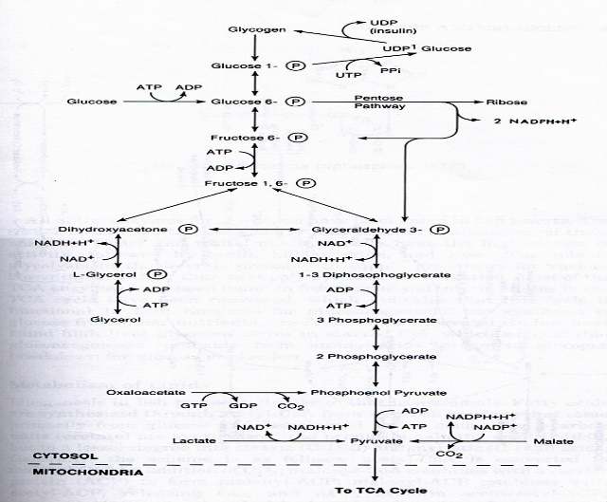
Fig 4. Glycolytic pathway in the body of fish
- The entire oxidation of glucose utilizes two mechanisms: glycolysis and TCA cycle
- glycolysis takes place in cytosol, TCA in the mitochondria
- TCA cycle utilizes a variety of substrates (e.g., amino acids, fatty acids, keto acids) for energy gain
- each turn on the TCA cycle = 15 ATP (w/2 molecules of pyruvate entering, this equals a total of 30 ATP (Fig. 5).
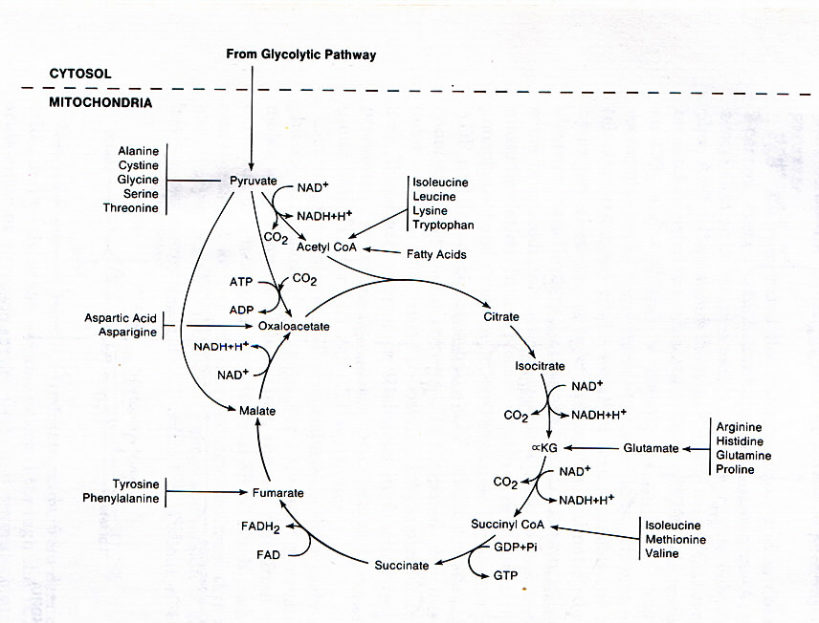
Fig 5. Tricarboxylic Acid Cycle

- All the previously shown enzymes for glycolysis/TCA have been identified in fish tissues
- those tissues showing highest enzyme activity are the heart and muscle tissue
- others include brain, kidney, gills, liver
- gluconeogenesis: synthesis of glucose as a result of starvation
Lipids
- Formation of lipids is known as lipogenesis
- formation is through compound known as acetyl CoA (entering into TCA cycle)
- fats are derived from the carbon skeleton found in all COH and non-essential amino acids
- Step 1: COH, NEAA broken down into 2-carbon units known as acetate
- Step 2: acetate converted to stearic acid or palmitic acid
- responsible enzyme: fatty acid synthetase
Fatty acids
- Once palmitate (16 C) has been formed, it can be elongated and desaturated by enzymes in the mitochondria
- the ability to chain elongate seldom exceeds 18 carbons in length
- FA’s (fatty acids) are added to glycerol phosphate (from glycolysis) to form a lipid
- primary site for FA synthesis is in liver and adipose
- Catabolism or oxidation of fatty acids in fish is similar to that of mammals
- once you hydrolyze the fat (remove FA’s) the glycerol moeity goes back into glycolytic pathway for energy production
- release of triglycerides from adipose is under hormonal control
- obesity: disease in which individual lacks ability to mobilize triglycerides
Amino acids
All amino acids have the same general formula:
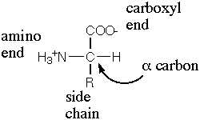
The twenty amino acids found in biological systems are:
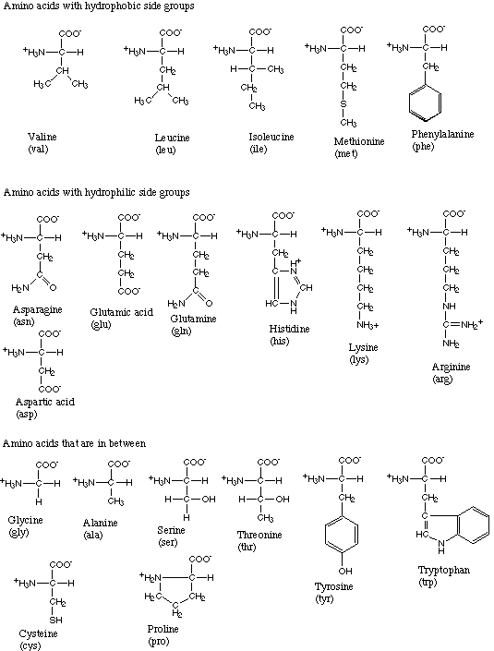
Fig 5. All proteins are linear chains composed of these 20 amino acids.
- Amino acids are “stored” in the body’s amino acid pool
- release is controlled by liver
- sources: dietary and catabolism of proteins
- protein metabolism: oxidation followed by energy release, carbon skeleton use for FA synthesis
- amino acids, unlike lipids and COH, are not stored in the body
- Excesses of AA’s (amino acids) in pool are deaminated and C-skel burnt for energy or converted to COH/lipid
- where do the amino (NH₃) groups go?
- They are transaminated (passed to a different C-skel) and eventually either excreted or used for subsequent AA synthesis
- Terrestrials excrete urine, birds excrete uric acid, inverts/fish largely ammonia

  - Energy partitioning

1.2.1 Energy Utilization
- Energy intake is divided among all energy-requiring processes
- Magnitude of each depends on quantity of intake plus animal’s ability to digest and utilize that energy
- Can vary by feeding mode: carnivorous vs. herbivorous

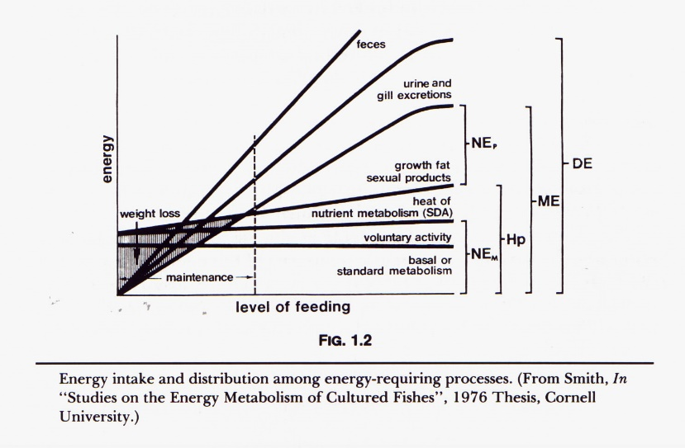
- Energy intake is divided among all energy-requiring processes
- Magnitude of each depends on quantity of intake plus animal’s ability to digest and utilize that energy
- Can vary by feeding mode: carnivorous vs. herbivorous
- Energy content of a substance is typically determined by completely oxidizing (burning) the compound to carbon dioxide, water and other gases
- the amount of energy given off is measured and known as gross energy
- gross energy (GE) is measured by a device known as a bomb calorimeter
- other devices: gradient chamber, infra red detector

  - Bioenergetic model

1.2.1 Energy flows in fish body
Energy flow as used in the body of fish is often shown as a diagram: every text has its own idea of a suitable diagram:

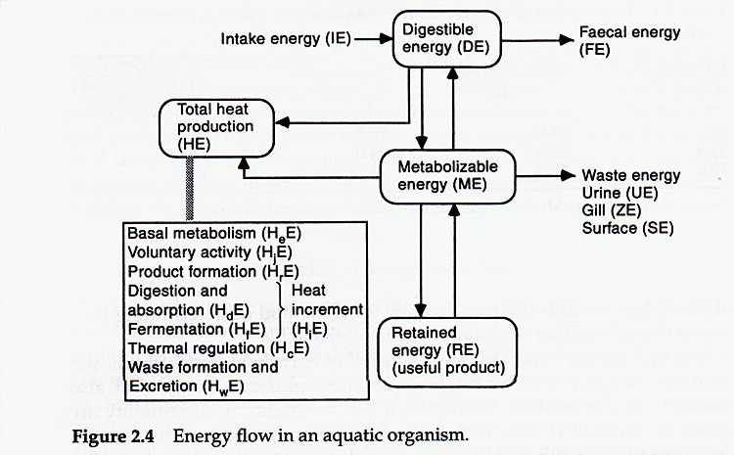
Fig 6. Energy flow in the body of fish referred to as bioenergetic model.
These are described by the terms as follows:
- Gross energy (GE): energy released as heat resulting from combustion (kcal/g)
- Intake Energy (IE): gross energy consumed in food (COH, lipid, protein)
- Fecal Energy (FE): gross energy of feces (undigested feed, metabolic products, gut epithelial cells, digestive enzymes, excretory products)
- Digestible Energy (DE): IE-FE
- Gross energy (GE): energy released as heat resulting from combustion (kcal/g)
- Intake Energy (IE): gross energy consumed in food (COH, lipid, protein)
- Fecal Energy (FE): gross energy of feces (undigested feed, metabolic products, gut epithelial cells, digestive enzymes, excretory products)
- Digestible Energy (DE): IE-FE
- Total heat production (HE): energy lost in the form of heat
- heat lost is sourced from metabolism, thus, HE is an estimate of metabolic rate
- measured by temperature change (calorimetry) or oxygen consumption rate
- divided into a number of constituents
- as per energy flow diagram èè
Total heat production
- Basic metabolic rate (H_{e}E): heat energy released from cellular activity, respiration, blood circulation, etc.
- heat of activity (H_{j}E): heat produced by muscular activity (locomotion, maintaining position in water)
- heat of thermal regulation (H_{c}E): heat produced to maintain body temp (above zone of thermal neutrality)
- heat of waste formation (H_{w}E): heat associated with production of waste products
- specific dynamic action (H_{i}E): increase in heat production following consumption of feed (result of metab), varies with energy content of food, especially protein
Learning Activities
Review report on proximate components feed and fish; Nutrient composition analysis of feed and fish tissues.
Critique on selected journal articles on energetics

Summary of Topic
Energy and growth of fish should be considered in terms of their nutritional energetics. Dietary excesses or deficiencies of useful energy can reduce growth rate. This is because energy must be used for maintenance and voluntary activity before it is used for growth. Dietary protein will be used for energy when the diet is deficient in energy relative to protein.When the diet contains excessive energy, feed intake is typically reduced. This also reduces intake of protein and other nutrients needed for growth

Further Reading Materials
De Silva, S. S. and Anderson, T.A. (1995). Fish Nutrition in Aquaculture, Chapman and Hall. London.
Lovell, R.T. (Ed.) (1998) Nutrition and feeding of fish. Second Edition. Kluwer Academic Publishers, Massachusetts.
National Research Council (NRC), (1993). Nutrient Requirements of Domestic Animals. Nutrient Requirements of warm water fishes and shell fishes. Revised Edition. National Academy Press, Washington DC, USA, 114 p.

Useful Links
NRC (1993) Nutrient requirements of fish. National Academy Press, Washington DC.http://www.nap.edu/books/0309048915/html/

New, M.B., Tacon, A.G.J. & Csavas, I. (1993) Farm-Made Aquafeeds. Published by RAPA 1993/18, AADCP/PROC/5, ISBN 974-89097-8-6, 434p http://www.fao.org/DOCREP/003/V4430E/V4430E00.HTM

Topic 2: Feeds and feed formulation

Learning Outcomes
By the end of this topic, you should be able to:
- Identify feed ingredients suitable for fish feed
- Formulate rations/diets for different fish species using tools and methods available

Key Terms
Feed ingredients; Trial and Error, Pearson’s Square; Linear Programming; Supplementary and complete diets; By-products.

Introduction to Topic
When fish are cultured in a system where natural foods are absent, such as raceways, tanks or where natural foods make only a small contribution to the nutrition of the fish, as in intensively stocked catfish or tilapia ponds, the feed should be nutritionally complete. However, where abundant natural food is available, supplemental feeds need not contain all of the essential nutrients.
Nutritionally incomplete feeds are usually specific for a fish species or culture system; supplemental feeds for tilapia culture would be used in fertilised ponds. The nutrient requirements presented in books i.e. NRC bulletins, and other publications were determined primarily with small fish and represent levels affecting maximum growth rate. Also, many of the requirements represent single laboratory experiments, and are unchallenged or unsupported by other studies.
Thus, many requirements are, at best, only rough approximations of the optimum amounts of nutrients for practical diets to grow fish to harvestable size. Management, environmental factors, and fish size can have an effect on dietary' nutrient levels for optimum performance. However, nutrient requirement data that are available serve relatively well as a basis to formulate highly productive, economical diets for commercial aquaculture.
In formulating a diet for a species where nutrient requirements are not known, the requirements for a related species whose nutrient requirements are known can be discretely substituted. Generally, most variation among fishes should be expected between warm- and cold-water species, fresh- and saltwater species, and finfishes and crustaceans.
2.1 Available ingredients
2.1.1 Practical feed ingredients
Ingredients used in practical fish feeds can be classed as protein (amino acid) sources; energy sources; essential lipid sources; vitamin supplements; mineral supplements; and special ingredients to enhance growth, pigmentation, or sexual development in the fish, or physical properties, palatability, or preservation of the feed. Some feed ingredients in common use worldwide and factors influencing their use in fish feeds are discussed in the following.
2.1.1.1 Fish Meal
Fish meal made from good quality whole fish that is properly processed is the highest quality protein source commonly available to fish feed manufacturers. It is a rich source of energy and minerals, is highly digestible, and is highly palatable for most fishes. Fish meal made from whole fish contains 60% to 80% protein which is 80% to 95% digestible to fishes. It is high in available lysine and methionine, the two amino acids most deficient in plant feedstuffs. Marine fish meal contains 1% to 2.5% n-3 fatty acids, which are essential in the diet of many fishes. Fish meal made from fish parts, such as waste from fish processing and canning plants, is lower in percentage and quality of protein. It is also high in ash and should be used prudently in fish diets to prevent mineral imbalances which could cause in availability of certain minerals.
2.1.1.2 Soybean Meal
Soybean protein has one of the best amino acid profiles of all protein-rich plant feedstuff's for meeting the essential amino acid requirements of fish. Based on NRC (1983) requirements, soybean protein is not deficient in any essential amino acid for channel catfish. Some fish find soybean meal unpalatable. Canadian research showed that soybean meal could comprise the major protein source in rainbow trout diets and produce satisfactory growth, but if the level of fish meal were reduced below approximately 18%, diet palatability was reduced.
Channel catfish satisfactorily consume all-plant diets in which solvent-extracted soybean meal comprises 60% to 70% of the formula. When commercially processed soybean meal replaces fish meal or other animal byproduct proteins in the diet, the losses in energy, minerals, and lipids should be considered. Dehulled soybean meal contains 25% less metabolizable energy (for rainbow trout), 86% less available phosphorus (for channel catfish), and 90% less n-3 fatty acids than anchovy fish meal. Soybeans contain several anti-nutritional factors, namely a trypsin inhibitor. Heating during commercial oil extraction (approximately 105¢J for 10¢J 20 min.) destroys most of these factors.
2.1.1.3 Other Oilseed Meals
Meals from peanut (groundnut) and sunflower seed have been used in fish feeds in the United States. Compared with soybean meal, these are deficient in lysine and methionine. Peanut meal produced in the United States contains around 48% crude protein, is highly palatable, and contains no toxins or anti-nutritional factors. It also has better binding properties for pelleting than soybean meal. Sunflower meal is also palatable, but relatively fibrous.
2.1.1.4 Grains and Byproducts
The primary nutritional contribution of grains is carbohydrate. Whole grains contain 62% to 72% starch, which is about 60% to 70% digestible by warm water fish but less than 40% digestible by saimonids. Heating increases digestibility 10% to 15%. Starch in grains is a valuable binding agent in steam pelleted and extruded fish feeds.
Yellow corn is the most widely fed grain in North America. It is low in protein, and the protein is poor in amino acid balance. It contains approximately 20 mg/kg to 30 mg/kg of the yellow-pigmented xanthophylls (leutin and zeaxanthin), which impart undesirable yellow color in certain areas of the flesh of white-fleshed fish.
Rice bran, which usually includes polishings, contains approximately 12% protein, 12% fiber, and 12% fat. It is often available at reasonable cost in developing countries where other ingredients may be prohibitively expensive. It is a good nutrient source, but does not pellet well because of the high fat and fiber contents.
Wheat is usually too valuable for human foods to feed to fish; however, small amounts of ground wheat are often used in fish pellets because of binding quality. Wheat gluten (protein) is an excellent binder. Wheat bran and middlings are commonly used in salmonid feeds because they contain more protein and less starch than whole grains.
2.1.1.5 Animal Byproducts
Meat and bone meal is a product of partially fat-extracted, dried slaughterhouse waste. It usually contains about 50% to 55% crude protein, with a significant amount of the protein coming from bone and other nonmuscle tissue. The quality of the protein is less than that of whole fish meal and varies considerably with the composition of the waste material. It is high in ash and therefore should not be used in unlimited quantity in fish feeds. It is a good source of energy, phosphorus, and trace minerals. Flash or spray-dried blood meal is highly digestible and rich in protein (80-86%). It is deficient in metbionine but rich in lysine. It is not as good a mineral supplement as fish meal or meat and bone meal because of absence of bone. Blood meal is unpalatable to some species. Poultry byproduct meal, without feathers, is a good source of animal protein for fish feeds; however, this product is usually recycled back into poultry feeds. Feather meal is a highly concentrated source of protein (80%), but quality is poor and digestibility is low unless the feathers are thoroughly hydrolyzed during processing.
2.1.1.6 Crustacean Meals
Shrimp waste meal is a useful feed ingredient if the heads are included. The exoskeleton is primarily chitin and has limited nutritional value; thus the visceral organs in the head section are most valuable nutritionally. In addition to supplying protein, shrimp waste meal is a source of n-3 fatty acids, cholesterol (essential for crustaceans), and astaxanthin (for red pigment in salmonids). It is highly palatable and may serve as an attractant in feeds for fishes and crustaceans.
2.1.1.7 Fats and Oils
Fats and oils are used as energy sources, to provide essential fatty acids, and to coat the outside of pelleted feeds to reduce abrasiveness (resulting in less fines) and minimize dustiness. Fats from livestock and poultry processing (animal fats) are highly saturated, but are effective sources of energy for warm and coldwater fishes. Marine fish oils are used in feeds for trout, salmon, and cultured marine fish because they are a source of essential (n-3) fatty acids. Marine fish oils contain on the average 20% to 25% of the long chain (over 20-carbon) n-3 fatty acids. Animal fats and vegetable oils do not contain fatty acids beyond 18 carbons and, except for soybean and linseed oils, most are low in n-3 fatty acids. Catfish oil, which is recycled back into catfish feeds, is similar to livestock and poultry fat in fatty acid composition.

2.2 Restriction in feed formulation
- There are number of restrictions that when formulating diets for different fish species are supposed to be observed. These restrictions can be set when formulating diets.
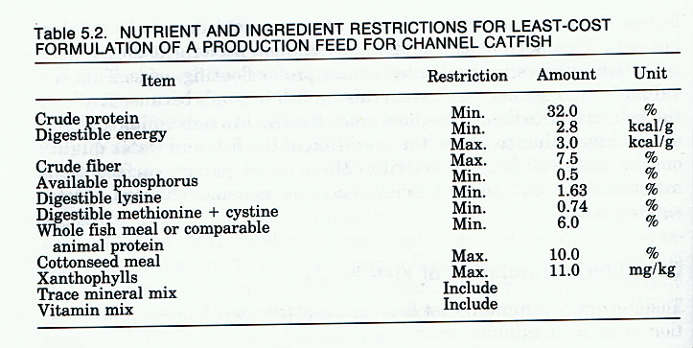
- these are nutrient and ingredient restrictions that have been used for least cost formulation of catfish feeds
- theoretically, protein level does not have to be restricted if essential amino acid requirements are well-known
- for catfish, if the minimum requirements for lysine and the sulfur-containing AA’s are met, other EAA requirements are also met
- minimum available phosphorus and digestible energy
- only maximum calcium is typically considered due to availability in water
- whole fish or other animal protein sources have been shown beneficial for catfish feeds
- cottonseed meal is restricted to 10% due to gossypol (protein) content (toxic)
- xanthophyll content often restricted due to it causing yellow discoloration of fish at high concentrations

2.3 Tools used in feed formulation
2.3.1 Feed formulation tools and methods
Ingredients could be chosen from well known list (Table 1) when preparing a supplemental feed, so that a feed mixture having the desired crude protein content is obtained. Inquire from poultry and livestock dealers and farmers what ingredients are locally available. There are methods that can be used to determine how much of a selected ingredient should be used for making a fish feed with desired crude protein content. The trial and error, Pearson's square and Linear programming methods are described below.
2.3.1.1 Method 1: Trial and error method
1) Choose a combination of ingredients from Table 1 that will provide a feed containing 25 to 30% crude protein.
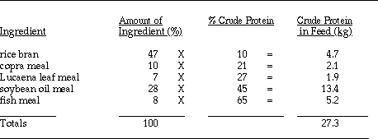
This feed would contain 27.3 kg of crude protein if 100 kg of the listed ingredients were combined as indicated. This would make a feed containing approximately 27 % crude protein by weight since (27.3 kg / 100) x 100 kg = 27.3 % protein content.
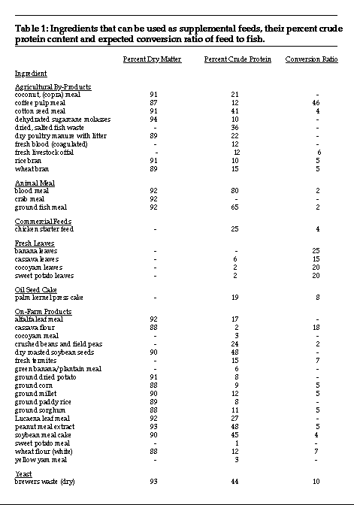
2.3.1.2 Method 2: Pearson's Square
This method may be used for two or more feed ingredients and is preferable to the trial and error method. Examples of feed formulations with two and more ingredients are shown.
Example 1: - two ingredients
Find the proportions of rice bran and fish meal required to make a feed containing 30 % crude protein.
1) Draw a square (See diagram on the following pages).
2) Place the desired protein level at the center of the square. In this case, 30 %.
3) Place the two ingredients on the two left corners of the square along with the protein
content of each.
4) Calculate the difference in crude protein content of the two ingredients (65 and 11)
and record this number (54) near the lower left corner of the square.
5) Subtract the desired protein level (30 %) of the feed from the protein content of each ingredient and place the answer in the corner diagonally opposite from each ingredient. Ignore positive or negative signs. The difference between percentages of protein in rice bran and in the feed (19) represents the amount of fish meal needed. The difference between fish meal and the feed (35) represents the amount of rice bran needed.
6) Add the differences obtained at the right corners of the square (19 and 35) and record their sum (54) near the bottom right corner. The sum in the right corner should equal the difference in crude protein content recorded near the lower left corner of the square.
7) Divide the sum obtained in step 6, which was 54, into each difference obtained in step 6, which were 19 and 35. Then multiply each by 100 to obtain the percentage of each ingredient needed for the feed.
Thus, 35 kg of fish meal and 65 kg of rice bran are combined to make 100 kg of fish feed containing 30% crude protein. The feed can also be described as being composed of 35% fish meal and 65% rice bran.
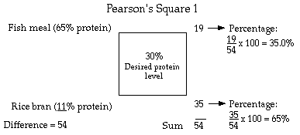
Example 2: - three or more ingredients
In this example, find the proportions of soybean meal cake, fish meal, ground corn and cassava flour needed to make a fish feed with a 30% crude protein content.
1) Draw a square and place the desired protein level (30%) at the center of the square. (See diagram on the following page).
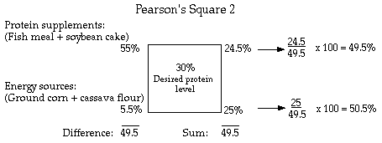
2) Group the ingredients into energy sources (crude protein less than 20%) and protein supplements (crude protein greater than 20%).
3) Calculate an average for the crude protein (CP) contents of each group of ingredients (Table 1).
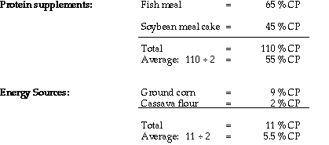
4) Place the averages obtained above at the left corners of the square.
5) Calculate the difference in crude protein content between the protein supplements and energy sources and record this near the lower left corner of the square. The answer in this case is 49.5.
6) Subtract the desired protein level (30 %) of the feed from the combined protein content of the protein supplements and energy sources and place the difference in the opposite diagonal corners. Ignore positive or negative signs. Results are 25 and 24.5, respectively for the protein supplements and energy sources.
7) Add these differences and record the sum near the lower right corner of the square. In this case, the answer is 49.5 on the left side and 49.5 on the right side.
8) Divide the left side sum (49.5) into each difference obtained in step 6 (24.5 and 25) and multiply by 100 to calculate the percentage of protein supplement and energy source needed for the feed. The respective answers are 49.5 % and 50.5 %.
9) One half of the protein supplement (24.75 %) is provided by fish meal and one half is provided by soybean oil cake. One half of the energy source (25.25 %) is provided by ground corn and one half is provided by cassava meal.
Thus, to make 100 kg of fish feed containing 30% crude protein from a combination of ingredients including fish meal, soybean meal cake, ground corn and cassava meal the following proportions would be mixed:
Fish meal 24.75 kg
Soybean 25.25 kg
Ground corn 25.25 kg
Cassava Flour 25.25 kg

2.3.1.3 Method 3- Linear programming
2.3.1.3.1 Principles of computer least cost formulations
- Least-cost feed formulation: a feed formula that is both nutritionally-complete (within limits) and with a minimum ingredient cost (within limits)
- now-a-days is developed and completed through the use of computers using linear-programming software
- typical packages: BLP88, Mix-it, Winfeed
- used by most feed mills/manufacturers
- Least-cost feed formulations require that the following information be provided:
1. cost of feed ingredients
2. nutrient content of feed ingredients
3. nutritient requirement of the animal
4. availability of the nutrient to the animal
- minimum-maximum restrictions on levels
- Costs of feed ingredients and nutrient content are fairly available for most commercial feedstuffs
- costs can be evaluated on a daily basis
- nutrient requirements are fairly well known
- the most critical piece of information regards digestibility/availability of nutrients within the feed ingredient
- various indices: DE, ME, APD, etc.

2.3.1.3.2 Limitations of computer assisted formulations
- Limitations to computer formulations exist and should be recognized
- where the computer says its ok, the experienced formulator knows differently
- example: too high fat content for pelleting
- example: sorghum might be as good as corn in an extruder, but not a pelletizer
- this is why advantages are maximized when a number of options are available
- Originally, the development of feed formulations was a real task
- mathematical models for formulating nutritionally-adequate diets at lowest cost were available
- however, everything had to be hand calculated
- feed formulation: the preparation of nutritionally-complete diets for feeding animals
- In many cases, logistics of obtaining ingredients and their storage limit the number of ingredients
- availability of feedstuffs is not as important as having the option to substitute
- must also take into consideration the physical, palatability, and toxicological properties of the feed
- nutrient availability also varies
- As mentioned, most least-cost formulae are derived by linear programming
- it has its disadvantage in that it uses data out of the NRC handbook for fixed, maximum growth rates
- it does not take into consideration optimum return on growth for various feed nutrient concentrations
- this requires regression analysis
- regression analysis is now being integrated into poultry formulae, probably not yet available for fish
Example:
Linear Programming Least-Cost Feed Formulation using winfeed 2.8


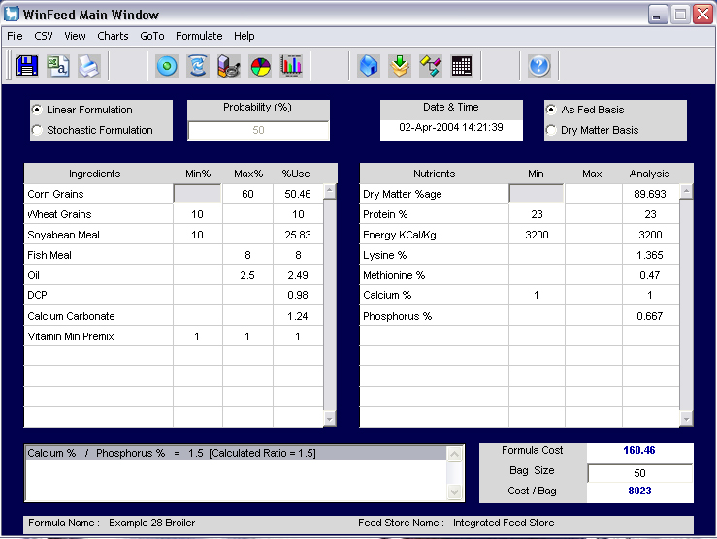
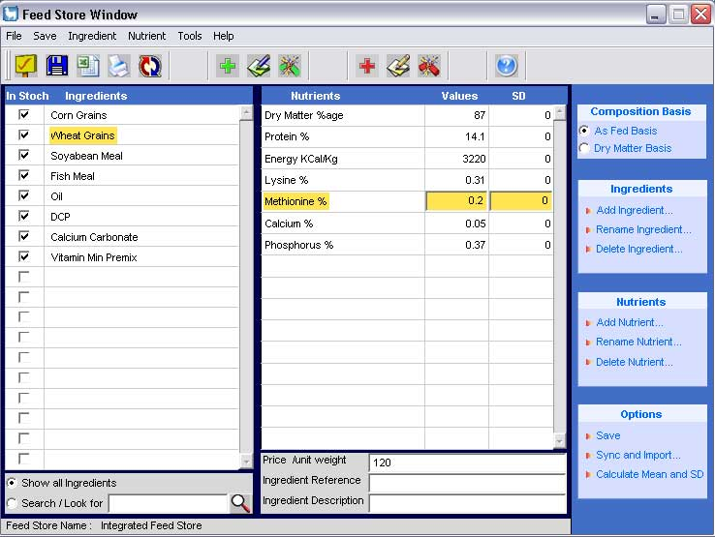
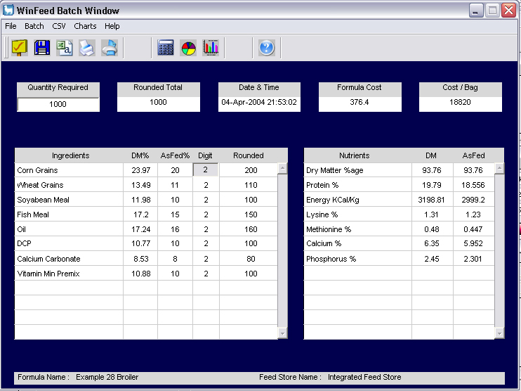

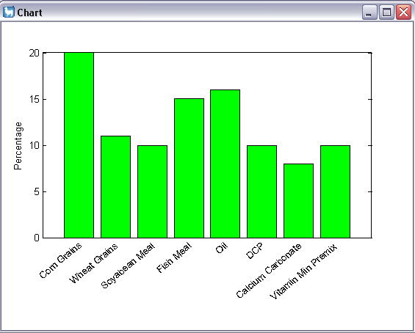
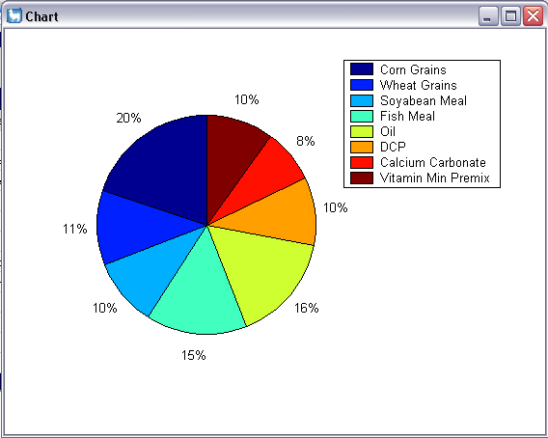

Input data into WinFeed
- Directly
- Excel file: Feed store
- Excel file: Nutrient requirements
Learning Activities
1. An assignment to compile an inventory of feed ingredients.
2. A practical on feed formulation using available tools and methods.
3. Critique on selected journal articles on feed formulation.

Summary of Topic
There are a number of locally available ingredients that can be utilised when formulating feed for different fish species. These include protein and energy sources for complete and supplementary diets. To formulate diets, different tools and methods can be used. These include trial and error, Pearson’s Square and Linear programming methods.

Further Reading Materials
Agricultural Software Consultants, Inc. (1997). MIXIT-WIN. Feed Formulation for Windows 95 or NT. Virginia.
De Silva, S.S. and Davy, F.B., (1993). Fish nutrition research for semi-intensive culture systems in Asia. Asian Fisheries Society 5: 129-144.
El-Sayed, A.M., (1999). Alternative dietary protein sources for farmed tilapia, Oreochromiss spp. Aquaculture 179: 149-168.
George F., H. P.S. Makkar and Klaus B. (2001) Antinutritional factors present in plant-derived alternate fish feed ingredients and their effects in fish. Aquaculture 199: 197–227
Hardy R. W. and F. T. Barrows. 2002. Diet formulation and manufacture. Pp. 505-600. In: Fish Nutrition. 3rd Ed. Elsevier Science. New York, USA.
National Research Council (NRC), (1993). Nutrient Requirements of Domestic Animals. Nutrient Requirements of warm water fishes and shell fishes. Revised Edition. National Academy Press, Washington DC, USA, 114 p.

Useful Links
NRC (1993) Nutrient requirements of fish. National Academy Press, Washington DC.http://www.nap.edu/books/0309048915/html/

New, M.B., Tacon, A.G.J. & Csavas, I. (1993) Farm-Made Aquafeeds. Published by RAPA 1993/18, AADCP/PROC/5, ISBN 974-89097-8-6, 434p http://www.fao.org/DOCREP/003/V4430E/V4430E00.HTM

www.aquafeed.com (reports on feed markets especially fishmeal, general aquaculture feed links)

http://usda.mannlib.cornell.edu (reports on feed markets)

http://www.fao.org/livestock/agap/frg/tropfeed.htm (tropical feeds database)
http://www.fao.org/docrep/003/V4430E/V4430E02.htm
http://www.ag.auburn.edu/icaae/

Topic 3: Anti-nutritional factors

Learning Outcomes
By the end of this topic, you should be able to:
- Identify different antinutritional factors present in feed ingredients and prepared feed
- Analyse selected antinutritional factors present in feed ingredients and prepared feed
Key Terms
Alternative protein sources; Protease; Saponins; Aflatoxins; Free amino acids; Anti vitamins; and Cyanogens.

Introduction to topic
Aqua-feed production is currently one of the fastest expanding agricultural industries of the world, with annual growth rates in excess of 30% per year. Thus, although the bulk of fishmeal is used in salmon, trout and marine fish farming in western countries, freshwater fish farming, largely that of carp, also consumes a substantial proportion and therefore alternative sources should be explored.

Most of the potential, alternative, plant-derived nutrient sources are known to contain a wide variety of antinutritional substances. There is lots of published work where the effects of inclusion of these materials in the diets of common culture fish are reported. A few studies in which plant-derived materials containing antinutrients have been included in fish diets and the effect of this inclusion on fish growth.

3.1 Types and their sources

Important antinutrients present in some commonly used alternative fish feed ingredients are summarized below:

Plant-derived nutrient source Antinutrients present
Soybean meal Protease inhibitors, lectins, phytic acid, saponins,
phytoestrogens, antivitamins, allergens

Rapeseed meal Protease inhibitors, glucosinolates, phytic acid, tannins

Lupin seed meal Protease inhibitors, saponins, phytoestrogens, alkaloids
Pea seed meal Protease inhibitors, lectins, tannins, cyanogens, phytic acid,saponins, antivitamins
Sunflower oil cake Protease inhibitors, saponins, arginase inhibitor

Cottonseed meal Phytic acid, phytoestrogens, gossypol, antivitamins,
cyclopropenoic acid

Leucaena leaf meal Mimosine

Alfalfa leaf meal Protease inhibitors, saponins, phytoestrogens, antivitamins

Mustard oil cake Glucosinolates, tannins

Sesame meal Phytic acid, protease inhibitors

3.2 Analytical procedures
There are methods for detecting the most common toxic and anti-nutrient factors whose presence can produce a negative effect on feed effectiveness and even cause mortality. These are considered to be particularly important when feed include agro-industrial by-products such as soyabean meal, cottonseed meal, or other sources of protein, especially those of plant origin.
The following recommendations should be observed for any of the analysis techniques:
- Make sure that the necessary reagents and equipment for the experiment are at hand because once an analysis has been started it cannot normally be suspended while missing elements are found.
- Make each analysis in TRIPLICATE; mean values give more accurate results than a single reading. If results vary significantly, the entire analysis should be repeated.
- Weigh samples as accurately as possible. Three or four decimal points will give greater precision in calculations. Always use precision scales.
- After transferring the sample to the analyzing vessel, weigh the container in order to adjust the final weight. Weight accuracy is very important for good results, since most of the techniques are gravimetric.
- Do not change sample weight, timing of the different stages or reagents unless prior tests have guaranteed accurate results. Remember that analyses are based on general standards accepted or demanded by regulatory authorities.
- Always use proper safety equipment and precautions such as fume extraction hoods, face masks and lab coats.
- You will be handling toxic or dangerous substances, so be extremely cautious in every step.
Procedures: Olvera-Novoa. M. A, Martinez-Palacios, c.a. and de león, e.r. (1994). FAO Analytical Manual

3.3 Their effects on growth of fish
Summary of some anti- nutrient factors identified in different feed ingredients.
Anti-Nutrient | Material | Effect
Protease inhibitor | Oilseeds including: Cotton (Gossypium spp.) Groundnut (Arachis hypogaea) Rape (Brassica campestris) Sunflower (Helianthus annuus) Soya (Glycine max) | Affects trypsin activity and makes the sulphurated amino- acid deficiency of plant protein more serious. Causes pancreatic hypertrophy associated with loss of endogenous proteins secreted by the pancreas, which are largely made up of cystine-rich enzymes.
 | Legumes including: Alfalfa (Medicago sativa) Kathin/Ipil-Ipil (Leucaena leucocephala) Canavalia (Canavalia spp.) Beans (Phaseolus spp.) Lupin (Lupinus albus) Cereals and their by-products | Heat labile.
Phytohaemagglutinins | Oilseeds including groundnut, soya Legumes including: Beans Peas (Cicer spp., Vigna spp., Cajanus spp., Pisum spp.) Cereals and their by-products | Cause blood clotting. Heat labile.
Phytic acid (phytates) | Oilseeds including: Groundnut, rape, soya cotton Sesame (Sesamum indicum) Legumes including beans, peas Cereals and their by-products | Form indigestible complexes with proteins, phosphorous, cal- cium, zinc, copper, magnesium, etc… causing mineral deficiency Not inactivated by heat.
Cyanogens | Oilseeds including linseed (Linum usi- tatissimum) Legumes including beans, peas Cassava meal and sorghum | Toxicity from cyanide.  Cooking destroys the enzymes that release the toxin and volatilizes the HCN.
Anti-vitamin factors: Anti-vitamin E Anti-vit. B₁₂, D, A | Soya, beans, alfalfa Soya | Reduce biological availability of vitamins. Destroyed by heat.
Micotoxins: Aflatoxins | Oilseeds including: Groundnut, rape, soya, sunflower, cotton Legumes including beans, peas Cereals and their by-products | High toxicity. Produced by mould (Azpergilus spp.) in im- proper storage conditions: high humidity and temperature. Also found in processed feed- stuffs.
Free amino-acids: Mimosine Canavanine | Legumes including: Kathin/Ipil-Ipil Canavalia, sesbania (Sesbania spp.) | Toxic at high levels; inhibit growth. Heat stable.

Learning Activities
1. Critique a journal article on antinutritional factors
2. A practical on laboratory analysis of selected antinutritional factors of interest.
3. Critique on selected journal articles on effect of antinutrients available in feedstuffs.

Summary of Topic
There are a number of antinutrients in plant based ingredients. Therefore it is important to note them and take precautions in terms of their levels and treatment. There are differences in tolerance in fish species.

The different tolerance limits of individual fish species to the presence of antinutrients also need to be considered before deciding on treatment procedures to reduce their levels. Tilapia species, for example, seem to be more tolerant
than carp to the increased presence of antinutrients in general. Feeding experiments using purified individual antinutrients may be needed to determine the threshold limits that will not affect the productivity of common culture fish.

Further Reading Materials
Olvera-Novoa. M. A, Martinez-Palacios, c.a. and de león, e.r. (1994). Nutrition of fish and crustaceans a laboratory manual. Food and Agriculture Organization of the United Nations – FAO Mexico City.
El-Sayed, A.M., (1999). Alternative dietary protein sources for farmed tilapia, Oreochromiss spp. Aquaculture 179: 149-168.
Francis, G, Makkar, H.P.S. ,.Becker, K., (2001). Antinutritional factors present in plant-derived alternate fish feed ingredients and their effects in fish. Aquaculture 199: 197–227

Useful Links

http://www.fao.org/DOCREP/003/V4430E/V4430E00.HTM

http://www.fao.org/livestock/agap/frg/tropfeed.htm (tropical feeds database)

Topic 4: Larval diet enrichments

Learning Outcomes
By the end of this topic, you should be able to:
- Identify different dietary enrichments procedures applied in various types of larval diets
- Analyse the effect of enrichment to various types of larval diets
Key Terms
Larval diets; Rotifers; Artemia; Cladoceran; Copepod; Enrichment.
Introduction to topic
Live food enrichments play an important role in delivering nutrients to fish larvae. Today, there are many enrichment products with different levels and ratios of EFA, anti-bacterial agents and vitamins. Species-specific enrichments are, however, lacking. Sometimes, especially with new species, it is desirable to have a product with a targeted nutritional profile.
A method of enriching fish food and live larval fish prey, especially Artemia nauplii and rotifers, with essentially highly unsaturated fatty acids, vitamins, amino acids, carotenoids and pigments. The live prey are allowed to ingest/adsorb the nutrients of interest. The live prey can be highly enriched in docosahexaenoic acid obtaining ratios of docosahexaenoic acid to eicosapentaenoic acid greater than about 2.0 to 1.0.
4.1 . Larval diets used in aquaculture
Larval diets include artificial formulated and the natural diets. The natural diets include the phytoplankton and zooplankton. These are given to the larvae before the yolk sac disappears and there after artificial formulated diets can be introduced. The popular natural diets with world wide applications include rotifers, artemia, cladocerans and Copepods among others. The concept of enrichment is as depicted in Fig 4.1.
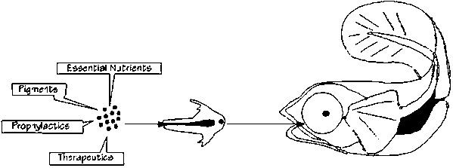
Figure 4.1. Enrichment procedure as understood by Larval Nutritionist (Source: Sogeloos, 2000).
4.2 Rotifer enrichment
The rotifer Brachionus has been used worldwide as a live food for the initial stage of larval rearing of marine fishes. These Brachionus species include Brachionus plicatilis O.F. Mu¨ller130–340 µm in lorica length) and B. rotundiformis Tschugunoff 100–210 µm. The former species inhabits colder waters 18–25 ºC., and the latter in waters of moderate temperatures of 28–35 ºC.
The ultra-minute Brachionus strains 90–150 µm are common in subtropical and tropical waters. These rotifers are probably included in B. rotundiformis; based on assays of male mate recognition, mate recognition pheromone MRP binding and anti-MRP binding. Mate recognition pheromone is localized on the female surface corona and cloaca, and is a 29-kDa glycoprotein.
4.3 Artemia enrichment
Artemia strains differ in size and nutritional quality, particularly in content of highly unsaturated fatty acids (HUFA). In the 1980s researchers found that fish larvae feed strains containing more than 4 percent eicosapentaenoic acid (EPA) 20:5 n-3 yielded ignificantly better growth in fish than Artemia with less than 3 percent 20:5 n-3. Recent research suggests that docosahexaenoic acid (DHA) 22:6 n-3 is more important nutritionally than EPA. These high EPA Artemia are not equal to HUFAenriched Artemia in terms of nutritional value, but are helpful in bridging the gap between rotifers and enriched day-old Artemia. The premium quality Artemia with high hatching rates, small size and greater HUFA levels are relatively expensive and sometimes difficult to find in quantity. As an alternative, a hatchery can purchase a commercial enrichment product to treat lower quality Artemia. Here is a simplified formula for Artemia enrichment.

Formula
Ingredients
- 800 ml deionized water
- 160 ml cod liver oil or other high omega fish oil
- 4 raw egg yolks (Egg yolks can be substituted with soybean lecithin—8 g or 5 percent of the weight of the oil.)
- 30 g unflavored gelatin
- 10 g vitamin premix, including E, C and B complex
- 1 g beta-carotene

Procedure
1. Dissolve gelatin in 800 ml boiled, deionized water and
let it cool to 40 ºC
2. Mix the oil in a blender on the highest setting for 30 seconds while adding betacarotene.
3. With blender on, add vitamins and egg yolks. Then add gelatin and blend for 90 seconds.
4. Store the product covered in the refrigerator.

For use with hatching Artemia
Use about 0.5 ml of the enrichment diet per liter of incubation water (assuming 2 g dry cysts per liter of incubation water). After 18 to 24 hours hatching time, add another 0.5 ml of the enrichment diet per liter 2
hours before harvesting. Harvest before Artemia become too large for fish larvae.

For use with hatched,separated Artemia (in seawater)
Use about 0.5 ml of the enrichment diet per liter of separated Artemia (assuming a density of 100 to 150
Artemia per ml) for not less than 4 hours.
Aerate the Artemia/diet mix during the enrichment process.
Cooling the water with ice may slow the rate at which the
Artemia grow during the enrichment process if size is critical to the target larvae.

The drawback to this procedure is that Artemia grow very rapidly, metamorphose to second instar metanauplii, and can become too large for some fish larvae to consume. The recommended solution is to use premium quality, newly hatched Artemia for the younger stages and then switch to enriched metanauplii Artemia as food for older fish larvae.

There are a number of enrichment products on the market. Artemia Systems I.N.V.E. (Gent, Belgium), Aquafauna Bio-Marine Inc., and Sanders Brine Shrimp Company are among the companies that carry these products. A number of companies are producing algae pastes or concentrates that also can be used as food supplements for Artemia.

4.4 Cladoceran enrichment
There are two major types of cladocerans which are commonly used. These include the moina and the daphnia. The cladoceran Moina is one of the more important live foods for tropical fishes, but the decline in agricultural land in many areas has produced a shortage that is affecting the farming of tropical fish. Thus it is important that ways be found to produce large quantities of Moina at minimal cost. Knowledge in the field of research on the mass cultivation of cladocerans is very much lacking. Feeding habits of Moina dubia and its role in the stabilization of sewage. Have been explored and found a large number of Moina dubia in the oxidation ponds and they feed voraciously on the algae present in the water which is very rich in organic and nutrient matter.
Mass cultivation of Daphnia pulex has been attempted in ponds and Daphnia magna has been reared in fish tank on rice bran and on algal food.
Enrichment of Moina can be done with the direct method, culturing them on baker's yeast and emulsified fish or cuttlefish liver oils. Experiments show that Moina takes up the (n-3) HUFA in the same way, although slower than rotifers and Artemia nauplii, reaching a maximum concentration of around 40% after a 24 h-feeding period.
4.5 Copepod enrichment
The nutritional quality of copepods is generally accepted to be very good for marine fish larvae, and believed to be of a higher quality than the commonly used live food Artemia. In general copepods have a high protein content (44-52%) and a good amino acid profile, with the exception of methionine and histidine
All copepods are not of equal value to the diet of larval fish. Larval fish require a particularly long chain highly of unsaturated fatty acids (HUFAs) in their diet to ensure the normal development of their nervous system. These HUFAs are not synthesized by animals but are produced by phytoplanktons. Well-fed copepods are likely to have stores of these HUFAs and therefore to be beneficial in the diet of fish. Those copepods, which feed by scavenging on detritus or by predation on ciliates or rotifers, have a larger proportion of fatty acids in their stores have been synthesized from bacteria rather from phytoplanktons. These copepods are of lesser value in their diet to larval fish.
If copepods, which store high levels of lipids and carry embryos in a clutch have suitable phytoplanktons in their diet, their value as a food item for fish increases. A healthy population of these phytoplankton-enriched copepods will include adult females with fresh algal food in their gut, lipids in storage and eggs developing in their reproductive tracts. Studies have shown these enriched animals to be preferentially selected by feeding fish.
Learning Activities
- Conduct culture and enrichments trials of copepods, rotifers, artemia, cladocerans and phytoplanktons using different types of enrichment nutrients.
- Critique on selected journal articles on use of enrichment in larval nutrition
Summary of Topic
Live feed is enriched to carry nutritious component that will be imparted to the larval fish after consumption of the live feed of interest. This is an important exercise mainly in marine fish where essential amino acids, essential fatty acids, vitamins are incorporated into the live feed to enhance better growth of the larval fish. Live feed like copepods, rotifers, artemia, cladocerans and phytoplanktons need to be enhanced for the better growth of the larval fish.
Further Reading Materials
Alam, J. 1992. Moina micrura (Kurz) as a live substitute for Artemia sp. in larval rearing of Macrobrachium rosenbergii (De Man), Doctoral thesis, Faculty of Fisheries and Marine Science, Universiti Pertanian Malaysia, 214 pp.
Rouse, D.B., Webster, C.D. and Radwin, I.A. 1992. Enhancement of the fatty acid composition of the nematod Panagrellus redivivus using three different media. Journal of the World Aquaculture Society, 23(1): 89-95.
Sorgeloos, P., P. Lavens, P.H. Leger, W. Tackaert and D. Versichele. 1986. Manual for the culture and use of brine shrimp Artemia in aquaculture. Artemia Reference Center, State University of Gent, Belgium.

Sorgeloos, P., 2000. Laboratory of Aquaculture & Artemia Reference Center, University of Gent, Belgium. Located on the Web at http://www.rug.ac.be/aquaculture.
Utting, S.D. 1993. Procedures for the maintenance and hatchery-conditioning of bivalve broodstocks. World Aquaculture, 24(3): 78-82.
Treece G. D. 2000. Artemia Production for Marine Larval Fish Culture. Southern Regional Aquaculture Center through Grant No. 97-38500-4124. SRAC Publication No. 702

Useful Links
http://www.aquaculture.ugent.be/Education/coursematerial/online%20courses/faoman/mcd/micro/harv.htm

http://www.fao.org/docrep/003/w3732e/w3732e00.htm#Contents

http://www.advancedaquarist.com/issues/feb2003/breeder2.htm

Topic 5: Digestibility assessment
Learning objectives
By the end of this topic, you should be able to:
- Describe digestibility determination procedures in fish.
- Determine digestibility of diets and individual ingredients in fish.

Key Terms: Digestibility, faecal output, feed intake, indicators.

Introduction to topic
The digestibility of feed is most accurately defined as that portion which is not excreted in the feces and which is therefore assumed to be absorbed by the fish. Ingredients of the diet must be digested and absorbed by the fish before nutrients can be used for growth, reproduction and other aspects of metabolism. Knowledge of availability of nutrients from various feedstuffs used in formulating cold/warm water fish species’ diets is desirable so that effective substitution of one ingredient for another can be achieved. Digestibility differs among species of fish raised under different environment al conditions. An important consideration in formulating feed is to maximize the efficient digestion and utilization of the component ingredient. Standard methods of determining nutrient digestibility and metabolizable energy in diets have been adapted for fish. In these methods, differences exist between fish and land animals. For fish the aquatic environment makes measurements of the feed intake and fecal output very difficult. The collection of feces for determination of nutrient digestibility differs between fish and domestic animals. Hence the collection and accurate analysis of fecal material may require special techniques considering small sizes of fish. The separation of waste products: feces, urine, gill excretion as well as a uneaten feed may require special techniques as well. Since fish are poikilothermic, their body temperature is not constant but depends upon the water temperature which varies with season and the time of the day. Water temperature change may therefore affect ability to digest, metabolize and absorb nutrients

5.1 Estimation of Digestibility Coefficients.
5.1.1 Fecal collection
The method of collecting feces in the water during digestibility trial any affect estimates of feed digestibility values for fish. There are three main ways of collecting fecal material tested and all of them have advantages and disadvantages in terms of leaching of nutrients. These include:
- Collecting from the water by netting, pippeting, mechanical filtration and settling
- Collection by stripping the fish by applying slight pressure upon its ventral surface between the ventral fin and the anus.
- Collection of fecal material by dissecting into several parts of the digestive tract of fish.

5.1.2 Digestible energy and nutrients
The amount of energy available to an animal from a feedstuff is known as its digestible energy (DE). DE is defined as the difference between the gross energy of the feed item consumed (IE) and the energy lost in the feces (FE). Two methods of determination: direct or indirect. The direct method, all feed items consumed and feces excreted are measured. The indirect method involves only collecting a sample of the feed and feces. Digestion coefficients are calculated on the basis of ratios of energy/nutrient to indicator in the feed and feces. The indicator should be an inert indigestible compound added to the feed at 0.5-1% of the diet. Examples of indicators: natural (fiber, ash) or synthetic (chromic oxide).

5.3 Direct method
Digestibility coefficients are calculated using the direct method using the following formula:
- % DE = Feed energy – Fecal energy x 100
Feed energy

  - Indirect method
Digestibility coefficients are calculated using the direct method using the following formula:

% DE = 100 - Fecal energy X Feed indicator x 100 Feed energy Fecal indicator

5.5 Metabolism of Energy and Nutrients
This is even more detailed distinction of energy availability. It represents DE minus energy lost from the body through gill and urinary wastes. It is much more difficult to determine because a researcher must collect all urinary wastes while fish is in water. Metabolism coefficient can is calculated using the formula below:
% ME = intake energy –(energy lost in feces, urine, gills) x 100
Feed energy
Use of ME vs DE would allow for a much more absolute evaluation of the dietary energy metabolized by tissues. However, ME offers little advantage over DE because most energy is used for digestion in fish. Energy losses in fish through urine and gills do not vary much by feedstuff. Fecal energy loss is more important. Forcing a fish to eat involuntarily is not a good representation of actual energy processes. All these methods determine apparent digestibility because no correction is made for endogenous material excreted in the feces.

5.6 Diet vs. individual ingredient digestibility assessment
The above procedures are meant to determine digestibility of a diet. However, there may be need to determine the digestibility of an ingredients. The following formula is used when determining digestibility coefficients of an ingredient of interest.
%AD = (AD_{td}-0.7AD_{rd})/0.3
Where:
AD is apparent digestibility
AD_{td} is apparent digestibility of test diet
ADrd is apparent digestibility of reference diet

5.7 Factors affecting digestibility
There are a number of factors that affect digestibility in fish. The following are some of the important factors that should be known:
- Feed composition
- Ration composition
- Feed preparation
- Enyzme supplementation in feed
- Fish species (animal factors)
- Level of feeding
- Temperature of water
- Salinity of water
Learning Activities
- Conduct feeding and digestibility trials of various feeds and feed ingredients
- Critique on selected journal articles on digestibility.
Summary of topic
Digestibility of diets and feed ingredients are important as they directly measure how much has been digested and metabolized. Solid waste water pollution in aquaculture has its origin in the feedstuff used, either as wasted feed or excretion from the fish. The wasted feed is due to overfeeding, while the solid excretion is mainly due to the indigestibility of the feed. To minimize this waste it is important to know the feed intake and the amount of solid excretion from the fish and how they are affected by the various feed ingredients and environmental conditions such as temperature.

Further Reading Materials
Austreng E. 1978. Digestibility determination in fish using chromic oxide marking and analysis of contents from different segments of gastrointestinal tract. Aquaculture 13: 165-272
Furukawa, A and Tsukahara, H., 1966. On the acid digestion method for determination of chromic oxide as an index substance in the study of digestibility of fish feed. Bulletin of the Japanese Society of Scientific Fisheries. Vol. 32 (6): 502-506.
Zhou, QC. Tan BP., Mai KS., Liu JY. 2004. Apparent digestibility of selected feed ingredients for juvenile corbia (Rachycentron canadum). Aquaculture 242: 441-451.

Useful links
http://pvj.com.pk/pdf-files/27_3/page%20121-125.pdf
http://journals.uzpi.cz/publicFiles/12390.pdf
http://www.pjlss.edu.pk/pdf_files/2004_2/2004_139-144.pdf
http://www.roquette-animalnutrition.com/deliaRessource/ressource_id-2888/ressource_url-/deliamedia28/2888_55ed00.pdf
http://www.ncbi.nlm.nih.gov/pubmed/2161667

Topic 6: Nutritional deficiency

Learning objectives
By the end of this topic, you should be able to:
- Explain the abnormalities and major nutritional and deficiencies experienced in Aquaculture.
- Describe specific deficiencies resulting from lack of protein and fats in fish under culture.

Key Terms: Protein and fat deficiencies, fish species, deficiency signs, nutrient.

Introduction to topic
The first action that a farmer usually takes when faced with a population of sick or dying fish is to call a veterinarian or fish pathologist. If on examining the fish no recognisable disease organism is found (ie. bacteria, virus or parasite) then the incriminating finger is usually pointed toward the diet of the fish or to water quality as being the cause of the problem. However, on calling the local feed manufacturer the sales representative more often than not tries to place the blame on poor water quality or on other non-feed related factors. Throughout the above chain of events the farmer generally still remains in the dark, continues to suffer heavy fish mortalities, and is desperately in need of an unbiased opinion and solution to his or her problem. Although the above scenario is gradually improving with the development of modern disease diagnostic laboratories, nutritionally related ‘disease’ problems still remain a largely uncharted territory, veterinarians usually being too busy coping with their routine disease diagnostic duties, and nutritionists usually not being interested nor scientifically qualified to undertake pathological analyses or make judgements on pathology related issues. Clearly, fish pathologists and nutritionists will have to work in tandem in the future if rapid strides are to be made in the emerging and commercially important field of nutritional fish pathology; nutritional fish pathology being concerned with the study of those health disorders/ailments (often inappropriately referred to as ‘diseases’) which result from nutrient deficiencies or dietary imbalances.
In contrast to extensive and semi-intensive farming systems were fish obtain all or part of their dietary nutrient needs from naturally available pond food organisms, fish maintained under intensive culture systems rely totally on the provision of a nutritionally complete diet throughout their life cycle. For many farmed fish the development of commercial feed rations has proceeded despite the lack of reliable published information being available on their dietary nutrient requirements. In view of this paucity of information it is perhaps not surprising that dietary related pathologies have often arisen from specific nutrient deficiencies and imbalances under practical farming conditions. The aim of this paper is to summarize the major nutritional pathologies which have been reported within farmed fish.
6.1. Signs of major nutritional deficiencies
These arise due to deficiencies of various nutrients. Lack of adequate levels of Protein, fats, vitamins and minerals.

6.1.2 Major disorders in dietary imbalances
Table 6.1 below summarises the dietary imbalances which have resulted in the manifestation of six major nutritional pathology conditions, namely 1) scoliosis/lordosis, 2) eye cataract, 3) fin erosion, 4) fatty liver, 5) exophthalmus, and 6) skin/fin haemorrhage. With the possible exception of the studies of researchers in the USA on the characterisation of eye cataracts in salmonid fish. There has been no systematic attempt to date to individually characterise the above mentioned conditions in fish. It is hoped that this review paper will stimulate further studies to be conducted under practical farming conditions so as to increase our understanding of nutritional fish pathology in fish.
Table 6.1. Major nutritional pathology conditions and reported causes
SCOLIOSIS/LORDOSIS Deficiency of | Tryptophan  Magnesium  Phosphorus  Vitamin C  Essential fatty acids (lordosis)
Toxicity of | Lead  Cadmium  Leucine  Vitamin A  Oxidized fish oil
CATARACT Deficiency of | Methionine  Tryptophan  Zinc  Magnesium  Copper  Selenium  Manganese  Vitamin A  Riboflavin
Toxicity of | Choline  Oxidized fish oil
FIN EROSION Deficiency of | Lysine  Tryptophan  Zinc  Riboflavin  Inositol  Niacin  Vitamin C
Toxicity of | Lead  Vitamin A
FATTY LIVER Deficiency of | Choline  Essential fatty acids
Toxicity of | Oxidized fish oil
EXOPHTHALMIA Deficiency of | Pantothenic acid  Niacin  Folic acid  Vitamin A  Vitamin E  Oxidized fish oil
Toxicity of
FIN/SKIN HAEMORRHAGE | Riboflavin
Deficiency of | Pantothenic acid  Niacin  Thiamine  Inositol  Vitamin C  Vitamin A  Vitamin K
Toxicity of
 | Oxidized fish oil

6.2 Protein, amino acids deficiency
Table 6.2 below summarizes major protein (amino acid) deficiency signs that occur in various types of fish.

Table 6.2 Reported essential amino acid (EAA) deficiency signs in fish.
Limiting EAA | Fish species | Deficiency signs
Lysine | Oncorhynchus mykiss | Dorsal/caudal fin erosion, increased mortality
 | Cyprinus carpio | Increased mortality
Methionine | O. mykiss | Cataract
 | Salmo salar | Cataract
Tryptophan | O. mykiss | Scoliosis, lordosis , renal calcinosis, cataract, caudal fin erosion, decreased carcass lipid content ; elevated Ca, Mag, Na and K carcass concentration
 |  | Scoliosis
 | Oncorhynchus nerka | Scoliosis , cataract
 | Oncorhynchus keta Oncorhynchus kisutch | Scoliosis
Miscellaneous | C. carpio | Increased mortality and incidence of lordosis observed with dietary deficiencies of leucine, isoleucine, lysine, arginine and histidine

6.3 Fatty acid deficiency
There are various deficiency signs that occur when essential fatty acids are lacking in fish feed. Table 6.3 below summarizes the deficiency signs of essential fatty acids.

Table 6.3 Report essential fatty acid (EFA) deficiency signs in fish
Fish species | Deficiency signs¹
O. mykiss | Increased mortality, elevated muscle water content, increased susceptibility to caudal fin erosion by Flexebacterium sp., fainting or shock syndrome, decreased haemoglobin and red blood cell volume, fatty infiltration and degeneration of liver, swollen pale liver , reduced spawning efficiency (low hatching and larval survival rate)
Oncorhynchus kisutch | Swollen pale liver, increased hepatosamtic index (fatty liver), high mortality
Oncorhynchus keta | Swollen pale liver, increased hepatosamtic index (fatty liver), high mortality
C. carpio | Increased mortality , fatty liver
Anguilla japonica | Increased mortality
Oreochromis niloticus | Swollen pale liver, fatty liver
Pagrus major | Reduced spawning efficiency (decreased hatching and survival rates, reduced appetite and growth, increased liver lipid content, high mortality
Lates calcarifer | Reduced growth and feed efficiency, reddening of fins
Scophthalmus maximus | Increased mortality, reduced growth, degeneration of gill epithelium
Ctenopharyngodon idella | Reduced growth and feed efficiency, swollen pale liver, increased mortality, lordosis, shock syndrome
Pseudocaranx dentex | Reduced appetite and swimming activity, reduced growth and feed efficiency, high mortality
Coregonus lavaretus | Reduced growth, feed efficiency and survival rate, swollen pale liver

Learning Activities
- Sampling of fish (Tilapia and Catfish) to identify major and specific nutritional deficiencies
- Critique on selected journal articles on effect of nutrient deficient diets on growth of fish.

Summary to topic
There are a number of nutritional deficiency signs that occur in fish when one of the nutrients are lacking in any diet fed to fish. The topic summarizes the major nutritional pathologies which have been reported in farmed fish. These include disorders in major nutrients such as protein, lipid and vitamins.

Further Reading Materials
Hargis,W.J., (1991) Disorders of the eye in finfish. Annual Rev. of Fish Diseases, 1:95–117
Hughes,S.G., (1985) Nutritional eye diseases in salmonids: A review. Prog. Fish-Cult., 47:81–85
Kincaid,H.L. & G.T.Calkins, (1991) Rapid classification of nuclear cataracts in lake trout. Prog.Fish-Cult., 53:120–124
Jauncey, K. 2006. Nutrition foundation modules. Postgraduate program. University of Stirling, Scotland, UK.
Tacon, A.G.J. 1992. Nutritional fish pathology. Morphological signs of nutrient deficiency and toxicity in farmed fish. FAO Fish Technical Paper. No. 330. Rome, FAO. 1992. 75 p.

Useful links
http://www.fao.org/docrep/r4807e/r4807e00.htm
http://www.fao.org/docrep/003/t0700e/t0700e00.htm
http://ag.arizona.edu/azaqua/ista/ista6/6abstracts/Ng/Ng_lipids.doc

Topic 7: Unconventional feed sources

Learning objectives
By the end of this topic, you should be able to:
- Identify potential unconventional sources of fish feed for Aquaculture.
- Describe specific use of potential legumes as alternative protein in fish feeds
- Explain how byproducts from the industries could be utilized as feed for fish.

Key Terms
Unconventional feed, legumes, industrial by products.

Introduction
The rapid world-wide expansion of aquaculture and livestock production strongly indicates that a crisis will be precipitated in the livestock and aquaculture feed industries in the near future. Food for humans is not included in this consideration because, generally speaking, livestock, fish and humans can all eat the same basic food commodities and, in emergencies or times of scarcity, feedstuffs are eaten first by humans.
Faced with the food supply problem for cultured fish, nutritionists have done more work evaluating alternate protein sources in aquaculture diets during the last 7 years than during the previous 50 years. A review of the literature shows that practically no potential feed material has been ignored. Table 7.1 categorizes these sources into three groups; i.e. vegetable and animal sources currently available, and potential sources not yet commercialized.
Feedstuffs of vegetable origin are as a whole lower in protein content when compared with those of animal origin. In addition, the presence of high amounts of carbohydrates, fibre, and other organic molecules such as glucosides, phytates, and cyclopropenes in these sources present the nutritionist with problems that are generally not encountered with sources of animal origin. Despite these problems, practically all the commercialized feedstuffs listed in Table 7.1 are being used to some extent in commercial aquaculture diets. None, however, perform as well as fish meal on a protein equivalent basis. The problems relating to their usage in fish diets will be discussed in greater detail in the next section.
Of the non-commercial items, only single cell protein (SCP), krill meal, and possibly leaf protein concentrate have a chance of becoming commercial within the shortest period of time. Because SCP are synthetic products and because the biomass of krill is so huge (the latter five times that of all landed fish), the volume of either could dwarf everything listed in Table 7.1 except soyabean meal.
Table 7.1. Alternate Sources of Protein that are Being Evaluated or have Potential as Partial or Whole Replacement for Fish Meal in Aquaculture Diets
Commercialized |  | Not commercialized
Vegetable | Animal
Soy meal | Poultry byproducts | Insect larvae
Rapeseed meal | Feather meal | Single cell protein
Sunflower meal | Shrimp and crab meal | Grasses
Oat groats | Blood flour | Leaf protein
Cottonseed meal | Fish silage | Vegetable silage
Wheat middlings | Meat meal | Zooplankton (krill, etc.)
 |  | Recycled wastes
 |  |  | Yeast
 |  |  | Phytoplankton
 |  |  | Bacteria
 |  |  | Algae
 |  |  | Higher plants
Protein (range), %
15-50 | 50-85 | 4-85

Feeds tuffs contain protein in amounts ranging from about 15 to 50 percent. This falls within the range of the protein requirements for optimum growth of several species of fish. However, proteins derived from vegetable sources are somewhat deficient in several key amino acids such as lysine, methionine, and tryptophane. This, of course, is not the only problem when unconventional sources of protein are used. A fish diet must provide a suitable energy source and be in proper balance with respect to:
(i) proteins,
(ii) minerals,
(iii) lipids,
(iv) carbohydrates, and
(v) vitamins and growth factors.
Then, there are the factors that relate to the feeds tuffs comprising the diet. These include:
(a) composition
The commodity must have a composition that allows it to be compounded into a balanced diet. For example, because of the high water content, it would be difficult to compound potential feeds tuffs such as sea plants, algae, etc., into diets.
(b) physical form
Many feedstuffs must be modified for proper formulation into diets. A common example in salmon diets is the lint that remains in cottonseed meal. It readily plugs the dies when small diameter feeds are to be prepared.
(c) palatability
Several potential feedstuffs contain compounds that are offensive to the olfatory receptors of the fish.
(d) factors affecting bio-availability of nutrients
(e) stability during storage
This primarily relates to the vitamin stability and also the stability of the lipid portion that may oxidize in either dry or frozen storage.
(f) toxic factors

7.1 Potential use of pigeon peas, bambara nuts, common beans, velvet beans, cow peas etc
Grain legumes or pulses occupy an important place in the world food and nutrition economy. Present world production is estimated to be more than 50 million metric tons and, at an average price of more than $400 per metric ton, its total value would amount to more than $2 billion. They are important constituents in the diets of a very large number of people, especially in the developing countries, and are good sources of protein which help to supplement cereal diets, improving their protein nutritive value. They also provide substantial quantities of minerals and vitamins to the diet. Although most legumes are consumed as dry grains, immature green pods or green seeds are also used as vegetables.
The availability of grain legumes over the last few years has dropped because their production has not been very profitable compared with that of other crops. The consumer demand for legumes has, however, not fallen and prices have increased considerably. Improved conservation and processing to reduce post-harvest losses, and the manufacture of economically priced products based on grain legumes will help to increase the supplies. The development of this industry would provide additional rural employment, improve nutrition standards, bring a better price to the grower, and ensure supplies at lower prices to the consumer.
In Asia and Africa, a substantial portion of the grain legumes is consumed after having been milled for removal of the husk and splitting, or after some form of processing. However, most of the commercial technologies available for this purpose are either obsolete or inadequate and result in heavy losses due to breakage and powdering of the grain. Successful efforts have been made to develop improved technologies to reduce milling losses and improve product quality. Similarly, there is need for development and utilization of improved technologies for the manufacture of products based on grain legumes.
Grain legumes are more difficult to store than cereals and they suffer much greater damage from insects and microorganisms. This not only results in quantitative losses, but also in qualitative reduction of the nutritive value because of vitamin loss and deterioration of protein quality. The milling losses in insect-damaged grain are even higher as more breakage and powdering occur with such grain.
Although many species and sub-species of legumes are known, only about a dozen of them are important as commercial food crops. (The common legumes and their botanical names are given in Table 7.1. The contributions of different legumes to the total world production and the major producing countries are listed in Table 7.2.) Beans and peas each account for about 25 per cent of the total production of legume crops. Chickpea and broad beans rank next in importance. Some of the legumes, however, are of only regional or local importance.
Table 7.2 Common legumes and their scientific names.
Common name | Scientific name
Peanut, ground-nut | Arachis hypogaea
Redgram, arhar | Cajanus cajan
Pigeon pea, yellow dhal, congo pea | Cajanus indicus
Chickpea, Bengal gram, garbanzo | Cicer arietinum
Horse gram | Dolichos biflorus
Lentil, masur dhal | Lens esculenta
Lentil, masur dhal | Lens culinaris
Lentil, masur dhal | Ervum lens
Broad bean, Windsor bean | Faba vulgaris
Soybean | Glycine hispida
Soybean | Glycine max
Soybean | Glycine soja
Lupin | Lupinus SPP
Velvet bean | Mucuna pruriens
Mung bean, green gram, | Phaseolus aureus golden gram
Mung bean, green gram, | Phaseolus radiatus
Mung bean, green gram, | Vigna radiate
Lima bean | Phaseolus lunatus
Black gram, urd, mungo bean | Phaseolus mungo
Kidney bean, navy bean, pinto bean,
haricot bean, snap bean | Phaseolus vulgaris
Pea | Pisum sativum
Winged bean | Tetragonolobus purpureus
Apart from the above list, many other leguminous seeds or their by-products have potential as aquaculture feed ingredients, though their successful use has not yet been fully assessed. These include those in Table 7.3
Table 7.3. Leguminous seeds with aquaculture feed potential
Common name | Special notes
Horse gram | low fibre
Cow pea | low fibre
Mung bean (black gram) | no glucosides; successfully used in aquaculture feeds
Tamarind | high fibre
Sesbania
Saman (rain tree) | high protein; high in tannins; used in experimental fish feeds
Red gram (dahl) | as good as soybean for poultry
Split peas (red dahl) | high protein bran
Lupin | high protein; bitter varieties contain alkaloids and must be soaked before use
Algaroba | ripe pods palatable to other animals
Senegal gum | high protein
Most of the leguminous seeds eaten by humans may be too expensive for use in aquaculture feeds but those of other legumes, either alone or together with the foliage of the plant, remain relatively unexploited sources for aquaculture. However, care should be taken to check their palatability and to remove toxic substances before their large-scale use.
7.2 Use of sugar byproducts i.e. bargasse
Efforts to reduce the cost of growout feeds for aquaculture have traditionally focused on the use of agricultural wastes as direct or indirect nutritional supplements to support semi-intensive production levels.. Waste products have been used as an ingredient of formulated feeds or as a fertilizer to enhance natural productivity of ponds. Considerably more research has been conducted on using wastes as pond fertilizers, especially in freshwater culture systems.

Sugar cane bagasse, because of its low cost and general availability in some areas, could be an attractive candidate for a pond supplement.

In an experiment with shrimps, growth rate in the bagasse treatments was superior to that achieved in this and previous studies using manure based fertilization.

Ponds that were part of the manure and bagasse-AM treatments had algal crashes at least once weekly after week 4, whereas crashes in the bagasse-NP ponds occurred infrequently. The lack of phytoplankton crashes might be explained by greater control of phytoplankton growth in the bagasse-NP treatment, through N and P additions determined by the Secchi reading. Although this does not imply a total ability to control
phytoplankton blooms, small inputs of N and P daily were certainly helpful in maintaining more consistent daily Secchi visibilities. After crashes occurred, ponds receiving either of the bagasse-based feeds appeared to recover their blooms more quickly than the manure-treated ponds. Measurements of natural productivity revealed that suspended biomass in the various ponds reached distinct plateaus of 2, 24, and 50 x 10⁸ cells per liter for the control, manure and bagasse-fed ponds, respectively.

The results of this study suggested that modest shrimp growth, at least to the 10 gram size animal, can be achieved at semi-intensive stocking densities using very low-grade nutrient inputs.

Bagasse has been used as feed for tilapia after incorporation into diets. The performance of the fish was generally good.

7.3 Use of industrial wastes of animal and plant origins.

7.3.1 Poultry By-Products and Feather Meal
Poultry by-products and feather meal have long been articles of commerce and their methods of production have been discussed elsewhere. Poultry by-products are primarily used by the pet food industry, and feather meal is a dietary ingredient, in poultry rations. They appear to be excellent protein and lipid sources containing 69 percent crude protein, 10-21 percent lipid and about 10 percent ash. The so-called hydrolyzed feather meal is really a misnomer. It is at best a slightly hydrolyzed product produced by cooking feathers in the presence of calcium hydroxide to increase its digestibility. Little, if any, free amino acids are found in this product. Feather meal has been evaluated in both fresh and salt water species. It contains about 80-85 percent protein and is a relatively good source of sulphur-containing amino acids. Whether these amino acids are completely available has not been demonstrated. Good results have been reported when it is used in catfish diets at the 15 percent level. Poultry by-products are lower in lysine than fishmeal, and trout diets containing over 75 percent poultry by-products would be deficient in the amino acid.
That some of the sulphur-containing amino acids in hydrolyzed feather meal are available to salmonids was recently demonstrated in feeding tests at the University of Washington. In these experiements, trout grew much better on mixes of feather meal and yeast SCP than when either of these commodities was used as the sole source of protein.

7.3.2 Single Cell Protein
Predictions of future protein shortages have spurred research on non-agricultural methods of protein production. As a result, certain types of high protein products suitable for feeding to livestock and fish are now produced on an industrial scale. Notable among these new protein sources, are single-cell organisms. Man has used single-cell organisms in connexion with his food supply for centuries, primarily in fermentation processes. The direct consumption by man and animals of single-cell organisms, however, is a recent innovation. More commonly referred to as single-cell protein (SCP) because they are high in protein contents this class of feeds tuffs are mainly derived from unicellular organisms such as yeast and bacteria, but can also include fungi and algae. SCP have reasonably well balanced amino acid profiles. When added to the diet of trout, some produced growth comparable to fish meal (Table 7.3). SCP are an excellent source of some vitamins and minerals and also possess usable lipids and carbohydrates.
Two commercial processes have been developed for large-scale production of SCP. One uses n-paraffin (C-10:C-23 range) as a substrate for growing yeast. The yeast organism most commonly cultured is Candida lipolytica. The other process uses methanol as a substrate and the organism of preference is Methylophilus methylotrophus. Both processes are similar in nature and the process for producing SCP of bacterial origin is schematized in Figure 5. To date, it appears that the process for SCP of bacterial origin is preferred for two very important reasons:
(i) Bacterial SCP produced from methanol is more easily purified. Yeast plants in-Italy and Spain have been closed down because of substrate contamination of the product.
(ii) The bacteria process operates at higher temperatures, 40-50° vs 37° for the yeast process. Since refrigeration is a major cost in operating the plants, operating temperature becomes a vital economic factor in SCP production. Bacterial SCP also has a higher protein content, about 70 percent as compared to 60 percent for yeast.
Table 7.3 Feed Conversion of Rainbow Trout Fed Experimental Diets Containing Single Cell Protein (Bacterial Origin) for 155 Days
 | Feed Conversion
% Substitution SCP | SCP added to diet | SCP replacing diet
0 | 1.22 | 1.24
25 | - | 1.25
50 | 1.26 | 1.26
75 | 1.26 | 1.32
100 | 1.26 | 1.29
SCP has been extensively evaluated with animals such as pigs, poultry, and calves; excellent results have been reported. Tests with fish have been conducted primarily with salmonids with variable results. In general, yeast SCP can be substituted for about 25-40 percent of, the fishmeal in standard OMP-type diets. Results of some of this work are depicted in Figure 7.1 and in Table 7.3.
To date, inconclusive results have been reported with SCP of bacterial origin. Successful substitutions have been made of the entire fish meal component with SCP bacterial in OMP-type diets for rainbow trout in fresh water. When these same diets were fed to coho salmon in salt water, it was possible to substitute only 25 percent of the fishmeal without adverse effects on growth and feed conversion. Fortification of the diets with iron, phenylalanine, and/or methionine did not alter growth or feed conversion. At present, tests are in progress to determine whether the dietary requirements for coho are different from rainbow trout or whether the salt water environment is a factor in the tests. One possible factor relating to the poorer performance of the bacterial SCP is the Ca/Mg ratio of the diet. OMP control diet contains a Ca/Mg ratio of about 6:1. Analyses of the bacterial SCP diets (100, percent substitution) show them to contain a Ca/Mg ratio of 16:1.
In discussing the use of SCP, one should not lose sight of the fact that spent brewer's yeast (BY) is a SCP source and also an article of commerce. It is often used in small quantities in preparing trout rations. Brewer's yeast contains about 45 percent protein, 8 percent fat, 13 percent ash, 10 percent water, and about 23 percent fibre and carbohydrates. It has an excellent amino acid profile, being deficient only in methionine. Recent work at the University of Colorado, however, has shown that when brewer's yeast contributed over 15 percent of the protein in the diet, growth of fish began to decrease. At the 50 percent level, growth was reduced by 30 percent as compared to fishmeal. These investigators showed that the primary problem was that of digestibility, the BY being only 53 percent digestible, with only 76 percent of the protein being digestible. Here again, the problem of the digestibility of a feed ingredient is an important factor in assessing the value of alternative feed sources.
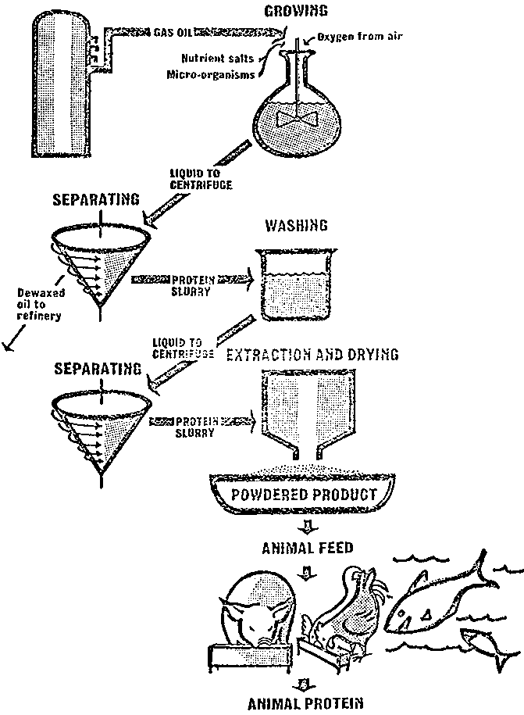
Fig. 7.1 Process for production of BP protein concentrate (British Petroleum Company)
INCLUDEPICTURE "http://www.fao.org/docrep/x5738e/x5738e2x.gif" \* MERGEFORMATINET INCLUDEPICTURE "http://www.fao.org/docrep/x5738e/x5738e2x.gif" \* MERGEFORMATINET 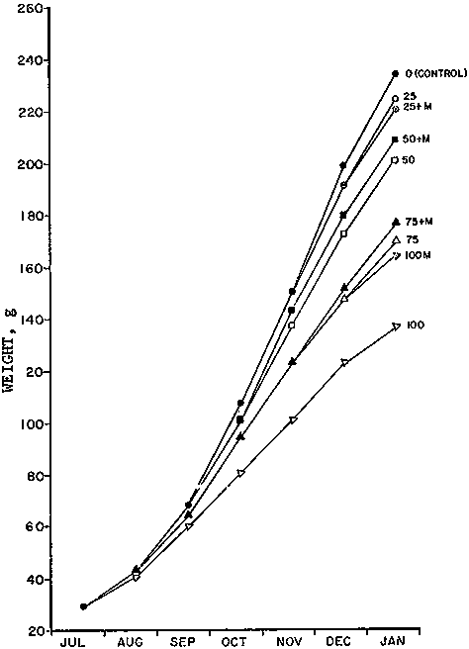
Fig. 7.2. Growth of saltwater-grown coho salmon fed Oregon moist pellet diets with 0-100% of herring meal replaced with yeast SCP. M indicates methionine fortification
SCP in the form of dried sludge has been evaluated. The sludge consisting of microorganisms grown on paper mill waste had a composition of 43 percent protein, 0.43 percent fat, 3.0 percent ash, 28 percent fibre and 15 percent carbohydrate. When substituted at the 25 percent level in trout diets containing 32 percent herring meal, growth and feed efficiency were significantly lowered; i.e., feed conversion went from 1.45 to 1.58 while percent daily weight gains fell from 18,2 to 13.7 percent, respectively. Amino acid analysis of the SCP used in these tests showed it to be deficient in phenylalanine, methionine, and arginine. SCP grown on potato wastes, on the other hand, could be substituted for about 40 percent of the total protein of OMP diets without significant loss of performance.
A danger associated with the use of SCP grown on industrial wastes is the possible risk of contamination with mycotoxins - aflatoxin, of course, being the more serious.
Learning Activities
- Produce an inventory of potential unconventional feed resources in Malawi, SADC and beyond
- Analyze their proximate nutritional composition for suitability
- Critique on selected journal articles on potential use of unconventional feed sources.

Summary to topic
Unconventional feed resources for fish feed are many but their potential is what remains to be explored more. There are potential leguminous sources that would substitute fish meal apart from conventional soybean. These have to be analyzed for the nutritional content to ascertain their quality and also their availability.
Most of the leguminous seeds eaten by humans may be too expensive for use in aquaculture feeds but those of other legumes, either alone or together with the foliage of the plant, remain relatively unexploited sources for aquaculture. However, care should be taken to check their palatability and to remove toxic substances before their large-scale use.
The leaves and stems of legumes are, like the grasses, widely used as fodder for terrestrial animals. A few (e.g., ipil-ipil and alfalfa) have successfully been used in feeds for aquaculture. Legume fodder is rich in protein and minerals. The seeds of legumes have a great potential value as aquaculture feed ingredients though many contain anti-nutritive factors when raw; processing (heat treatment) usually renders them safe for use. Leguminous seeds are often rich in lysine though poor in methionine. Whole beans and peas are used extensively as human food. They are therefore usually expensive ingredients and their use in aquaculture feeds may only be justified in diets for high-value export-oriented species. Some examples of leguminous plants, which all have the ability to convert gaseous nitrogen into protein, are acacia, clover, lucerne, groundnut (peanut), gram, lentil, locust beans, chickpea, guar, ipil-ipil, lima beans, field peas, mung bean, cowpeas, and soybean.

Further Reading Materials
El-Sayed, A.-F.M. 1999. Alternative dietary protein sources for farmed tilapia, Oreochromis spp. Aquaculture 179: 149-168.

El-Sayed, A.-F.M. 1991.Evaluation of sugarcane bagasse as feed ingredient for the Tilapias Oreochromis niloticus and Tilapia zilli. Asian Fisheries Society, 4:53-60.

Freeman, D.W., Duer, E.O. and Leber, K.M. 1992. Use of Bagasse as a Feed Input to Semi-Intensive Shrimp Growout Ponds. World Aquaculture Society, 23:23-30.

Spinelli J.1980. Unconventional Feed Ingredients for Fish Feed in ADCP/REP/80/11 - Fish Feed Technology. United Nations Development Programme. Food and Agriculture organization of the United Nations Rome,

Useful links
http://www.fao.org/docrep/x5738e/x5738e0d.htm
http://www.fao.org/docrep/003/V4430E/V4430E00.htm#TOC

Topic 8: Supplementary and complete diets

Learning objectives
By the end of this topic, you should be able to:
- Explain the rationale of using supplementary and complete feed in Aquaculture.
- Describe various types of supplementary and complete feed and their effect on growth of fish.

Key Terms: Supplementary, complete, fertilization, semi-intensive and intensive systems.

Introduction
Perhaps semi-intensive aquaculture will continue to remain a term and a practice that will never be defined precisely. On the other hand, some might argue that such a definition is not strictly needed, and that perhaps broadly accepted guidelines are sufficient.
One of the best available guidelines depicting semi-aquaculture practice was presented schematically (Figure 8.1). Accordingly, semi-intensive aquaculture would constitute a significant quantum in the continuum between extensive and intensive aquaculture. Within this broad spectrum the semi-intensive practices could differ from each other in the degree of management, provision of feed, the stocking density and yields.
Semi-intensive is characterised as follows:
- Stage 1: provision of natural food only (enhanced via fertilization) e.g. fertilized pond fish culture
- Stage 2: provision of natural food + substrate for energy metabolism e.g. growing tilapia in fertilised pond and use rice bran as supplementary feed.
- Stage 3: provision of natural food + energy + some building blocks e.g. Growing catfishes with soybean cake and noodle waste in Thailand
- Stage 4: provision of natural food +energy + building blocks +catalysers e.g. growing fish using formulated feed containing oil cakes, rice bran, di-calcium phosphate and salt as in carp culture systems in India.
The use of manure in fish farming is an old Asian practice, and has been adequately reviewed. The influence of manure on aquaculture is schematically depicted in Figure 8.2. Manure is thought to act in supplying a deficiency; in this case primarily nutrients in the culture system, supplementation of which enhances the growth of natural food organisms.

INCLUDEPICTURE "http://www.fao.org/DOCREP/003/V4430E/V443021.jpg" \* MERGEFORMATINET INCLUDEPICTURE "http://www.fao.org/DOCREP/003/V4430E/V443021.jpg" \* MERGEFORMATINET 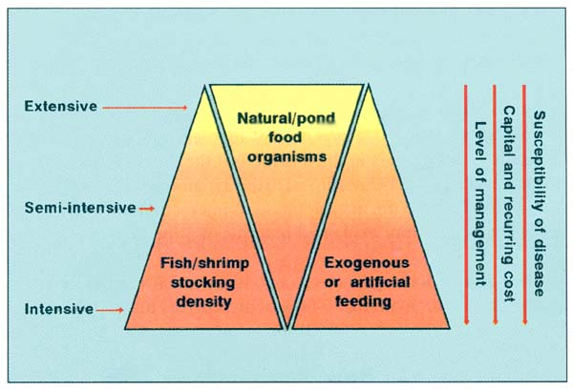
Figure 8.1. Schematic representation of the range of aquaculture practices in relation to the inputs (modified after Tacon 1988)

Hence, it is suggested that manure be considered as an indirect feed supplementation; perhaps a supplementation that is least competitive with the other forms of direct or indirect nutrient supplementation that are used in semi-intensive aquaculture. On the other hand others suggest that a better approach to carp culture would be to introduce live plankton rather than direct manuring. Here again, the question of wide-scale adoption of such a practice by the small-scale farmer arises.

INCLUDEPICTURE "http://www.fao.org/DOCREP/003/V4430E/V443022.jpg" \* MERGEFORMATINET INCLUDEPICTURE "http://www.fao.org/DOCREP/003/V4430E/V443022.jpg" \* MERGEFORMATINET 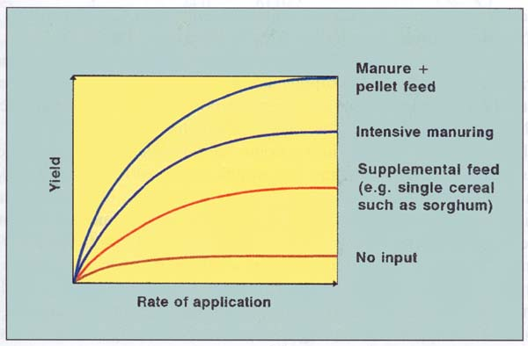
Figure 8.2. Schematic depiction of the influence of application of manuare in comparison to other inputs on yield in semi-intensive aquaculture
On the other hand, complete feed is a nutritionally adequate feed for animals other than man: by specific formula is compounded to be fed as the sole ration and is capable of maintaining life and/or promoting production without any additional substance being consumed except water.

8.1 Rationale of using supplementary diets
Supplement: is a feed used with another to improve the nutritive balance or performance of the total and intended to be:
(i) fed undiluted as a supplement to other feeds; or
(ii) offered free choice with other parts of the ration separately available; or
(iii) further diluted and mixed to produce a complete feed
8.1.1 Interactions with natural food supplies
Supplementing the naturally available food in a culture system is the most simplistic functional interpretation of supplementary feeds. In reality, the role of supplementary feeds in the nutrition of the cultured organism is much more intricate and is closely interlinked to the dynamics of the pond/system. The intricacy is analogous to the interpretation of interactions between species in a simple aquatic community explained in terms of a food chain as opposed to a food web.
The natural food organisms in a pond are a rich source of protein, often the mix of organisms containing 50-60% of protein (dry matter basis). Proximate composition of some of the common individual food organisms is given in Table 3. Thus it is evident that the nutritional value of natural food organisms is adequate to meet the nutritional requirements of most of the semi-intensively cultured organisms in Asia. It has also been shown, for example, that the food of tilapia (Oreochromis mossambicus), from quasi-natural impoundments, even when it contains a high proportion of detritus, is well digested.
In semi-intensive culture there are complex interactions between the natural food organisms and supplementary feeding practice(s). The possible qualitative interactions in a well prepared pond which is to be subjected to supplementary feeding is schematically depicted, in Figure 7. The above simplification does not take into account the possible changes in the feeding habits of the cultured organisms. The trophic niches of fish species are known to change with natural food productivity, the standing crop of fish and the plasticity of the feeding behaviour. There is some experimental evidence to show that, as the difference between standing crop (SC) of the cultured organism(s) and the critical standing crop (CSC) of natural food organisms increases, the deficit in natural protein supply also increases. Under such conditions supplementation with “protein rich” diets becomes necessary to maintain growth and production.
Table 3. Proximate analyses of organisms serving as food for pond fishes
 | Dry matter composition*
Organism/group | Dry matter | Protein | Carbohydrate | Lipid | Ash | Energy
 | (%) | (%) | (%) | (%) | (%) | (kcal/kg)
Bacteria |  |  |  |  | 5.4 | 4,710
Algae
Cyanophyta (blue greens) |  | 31.3 |  |  | 46.7 | 2,213
Chlorophyta (greens) | 16.8 | 17.6 |  | 3.7 | 26.9 | 3,773
Phaeophyta (brown algae) | 14.1 |  |  |  | 32.3 | 3,056
Bacillariacaea (diatoms) |  | 30.7 |  | 9.9 | 38.3 | 3,654
Rhodophyta (red algae) | 21.7 |  |  |  | 32.1 | 3,170
Aquatic macro-vegetation | 15.8 | 14.6 |  | 4.5 | 13.9 | 3,906
Protozoa |  |  |  |  |  | 5,938
Rotifers | 11.2 | 64.3 |  | 20.3 | 6.2 | 4,866
Oligochaetes | 7.3 | 49.3 |  | 19.0 | 5.8 | 5,569
Leeches | 24.0 | 61.0 |  |  | 5.1 | 5,432
Crustacea
Anostraca (Artemia) | 11.0 | 61.6 |  | 19.5 | 10.1 | 5,835
Cladocera | 9.8 | 56.5 | 28.2 | 19.3 | 7.7 | 4,800
Copepoda | 10.3 | 52.3 | 9.2 | 26.4 | 7.1 | 5,445
Ostracoda | 35.0 | 41.5 |  |  |  | 5,683
Malacostraca (higher Crustacea) | 24.6 | 49.9 | 18.4 | 20.3 | 19.6 | 5,537
Insects | 23.2 | 55.9 | 20.1 | 18.6 | 4.9 | 5,075
Plecoptera (stone flies) |  |  |  |  |  | 4,900
Ephemeridae (mayflies) | 17.6 | 50.2 |  |  | 3.7 | 5,646
Odonata (dragon flies) | 21.1 | 51.9 |  |  | 5.8 | 4,985
Hemiptera (water bugs) | 26.0 | 68.8 |  |  |  | 5,150
Trichoptera (caddisflies) | 14.8 | 34.7 |  |  | 11.8 | 5,019
Diptera | 16.0 | 55.3 |  |  | 6.9 | 5,177
Chironomids (larvae) | 19.1 | 59.0 | 22.5 | 4.9 | 5.8 | 5,034
Molluses | 32.2 | 39.5 | 7.5 | 7.8 | 32.9 | 3,889
Aquatic detritus | 91.5 |  |  |  | 12.4 | 4,701
* since the values are averages of figures collected
from different sources they do not necessarily add up to 100%. Source: modified from Hepher (1988)
8.1.2 Supplementary Feeding
  - As stocking densities increase there comes a point beyond which yield will not increase without the supply of nutrients to the culture system.
  - Initially, in ponds at least, these additional nutrients may supplied by fertilisers which further stimulate natural productivity allowing an increase in stocking density and yield.
  - However, this increase then reaches a point beyond which further stimulation of natural productivity is not possible.
  - If still higher yields and stocking densities are required then exogenous dietary nutrients must be supplied to the ponds.

- Use of and nature of supplementary feeds must be decided with reference to:
  - the fish being cultured
  - the culture system in use (they are most appropriate to culture in earth ponds)
  - the natural productivity of the water body in question (and the physico-chemical properties of that water) and the degree to which natural production has been stimulated by fertilisation
  - the availability of suitable raw materials for supplementary feed production and the availability of suitable methods for processing the raw materials and supplementary feeds
b) Selection of raw materials influenced by:
  - cost - any potential supplementary feed material must be available at little or no cost to the farmer
  - availability - the feed material should, wherever possible, have year round availability
  - handling and processing - the requirements, prior to feeding, should be minimal (including transportation)
  - nutritional value - materials with high protein and low fibre contents generally have higher nutritional values than those with high fibre and low protein contents

c) Materials to be considered for supplementary feeds will include:
  - Kitchen/cooking waste, beer/brewing waste, spoiled/ contaminated animal feeds, pasture/arable crop wastes, aquatic macrophytes, mill sweepings, abattoir waste, fruit wastes, oilseeds and residues, cereal grain residues, sugar cane wastes, terrestrial invertebrates, aquatic animals

d) In general the ‘feedstuff’ categories you need to consider will be:
  - Animal products, plant products, microbial products, industrial/miscellaneous products, brewing and distilling by-products, silage products, lipid products

e) ‘Formulating’ supplementary feeds:
  - difficult to know what you need to supplement
  - natural food rich in protein so generally supplement energy
  - unless very intensive pond culture, generally no need to supplement micronutrients like vitamins
  - in complete feeds nutrient density decreases with increasing fish size/age whilst for supplementary feeds nutrient density increases with increasing fish size/age

f) General guidelines:
  - newly stocked, fertilised, ponds with low biomass of fish per unit area require no supplementary feeding
  - for low yields (<1000kg.ha-1) supplementary feeds are unnecessary (given adequate fertilisation)
  - for medium yields (1000 - 3000kg.ha-1) supplementary feeds can consist of very simple materials such as a cereal or cereal by-product
  - for high yields (>3000kg.ha-1) towards the end of the production cycle more sophisticated supplementary feeds, such as a 25% protein pellet, are recommended
  - as the biomass per unit area increases supplementary feeding rates should increase progressively
  - the figures given above are generally conservative and higher yields can almost certainly be achieved, with tilapia, at all levels of feed input

g) Form of feed:
  - raw, unprocessed
  - raw material has undergone some form of processing but there has been no effort to affect the final form of the diet
  - raw and/or processed materials formed into a simple ‘dough ball’ (often involving cooking of starchy carbohydrates)
  - raw and/or processed materials formed into a moist or semi-moist pellet
  - raw and/or processed materials formed into a dry pellet

h) Method of presentation:
- Broadcast by hand, use of feeding trays, use of suspended perforated containers, use of feeders (if dry pellet).
8.2 Rationale of using complete diets
Complete diets are used in Intensive systems where there is no internal source of feed but provided to meet the nutritional requirements of particular species of fish at different stages e.g starter, grower and finisher. They are characterised high protein levels and include mostly the additives which are ingredients or combination of ingredients added to the basic feed mix or parts thereof to fulfil a specific need. Usually used in micro quantities and requires careful handling and mixing.
Complete diets are usually used in indoor production systems or in cage culture systems for maximum production of fish. It is therefore wasteful to use complete feed in ponds unless they are not fertilized or there is minimum production of natural feed. So many recipes have been developed for various types of fish at different stages of production. They are preferably made into a Compound feed by mixing various products of vegetable or animal origin in their natural state, fresh or preserved, or products derived from the industrial processing thereof, or organic or inorganic substances, whether or not containing additives, for oral feeding e.g. formulations in the table below are complete diets.
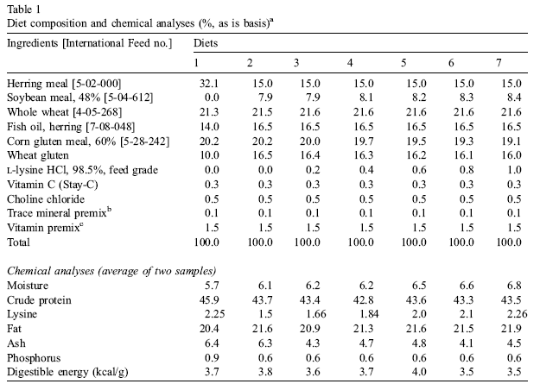
Learning Activities
1. An assignment: A discussion on rational of growing tilapia in:
- Semi-intensive system
- Intensive system
2. Critique on selected journal articles on use of complete vs supplementary feed.

Summary
Understanding the use of supplementary diets in the Semi-intensive system is important as you understand the species of fish to keep and level of feeding and the potential yields per unit area. The supplementary feeding is done under pond condition where the waters are fertilized to increase natural production and there fore the supplementation is addressing unknown nutrient requirement of the fish species cultured. On the other hand, complete diets are intede4d to be formulated to contain all the nutrient requirement of the fish. This type of culture of fish is termed as intensive system where no internal sources of natural feed is absent in the system there by relying on the external artificial feed.
Understanding of the rational of the two concepts distinguishes the level of operation and planes of nutrition that should be deployed. It is therefore wasteful to over formulate feed for semi-intensive system as supplementary diets are necessary and therefore the pond must be fertilized to have adequate natural food to sustain the growth of fish with a certain carrying capacity.

Further Reading Materials
Azim, M.E., Verdegem, M.C.J., van Dam, A.A., Beveridge, M.C.M. (eds.),2005. Periphyton: Ecology, Exploitation and Management. CABI Publishing, Wallingford, UK, 320 p.

AAFCO (Association of American Feed Control Officials). 2000. 2000 Official Publication, Association of American Feed Control Officials Inc. West Lafayette, IN 47971 USA, 444p.
Goddard, S. 1996. Feed Management in Intensive Aquaculture. Chapman and Hall. New York, USA.
New, M.B.; Tacon, A.G.J.; Csavas, I.(eds.). 1994.Farm-made aquafeeds. FAO Fisheries Technical Paper. No. 343. Rome, FAO. 434 p.
Tacon, A.G.J. 1988. The nutrition and feeding of farmed fish and shrimp - a training manual. 3. Feeding methods. FAO Field Document, Project GCP/RLA/075/ITA. Field Document 7/E, FAO, Brasilia, Brazil. 208 p.

Useful links
http://www.fao.org/DOCREP/003/V4430E/V4430E00.htm#TOC
http://www.aafco.org
http://www.fao.org/docrep/003/V4430E/V4430E02.htm

Topic 9: Live feed production

Learning objectives
By the end of this topic, you should be able to:
- Explain live feed production techniques practiced in Aquaculture.
- Describe specific production lines for major live feed produced to feed fish under culture.
Key Terms
Live feed, Zooplankton, phytoplankton, natural and artificial production.

Introduction
Whereas in the seventies aquaculture production of marine fish and shrimp relied mainly on the capture of wild fry for the stocking of grow-out tanks, ponds or cages, the commercial feasibility of complete domestication of many aquaculture species was demonstrated in the last two decades. The controlled cultivation of (post) larvae from broodstock, or in other words the hatchery production of fry, has become a general practice worldwide for many species of fish and shellfish. Today, for example, billions of shrimp postlarvae, billions of salmon smolts, over 150 million of European seabass and seabream fingerlings, some 200 million of Japanese bream and flounder fry, over 100 million of milkfish fry, etc., are being produced annually from the egg stage onwards.
Cultivation of larvae is mostly done under controlled hatchery conditions and requires specific culture techniques different from the nursery and ongrowing procedures, especially with respect to zootechnics, feeding strategies and microbial control. The reason being that larvae, compared to ongrowing juveniles, are very small, extremely fragile, and not fully developed. Especially their small size (of the mouth), the uncompleted development of their perception organs (eyes, chemoreception) and their digestive system, are limiting factors in proper feed selection and use during the startfeeding period.
In shrimp, these are not the only problems as larvae furthermore pass through different larval stages eventually changing from a herbivorous filter-feeding behaviour to become a carnivorous hunter. Therefore, larviculture nutrition, and more particularly start feeding in the early larval stages, appears to be a major bottle-neck for the industrial upscaling of the culture of many fish and shellfish species. A few examples may further illustrate this.
- Larval (mouth) size at start feeding
The mouth size of a first-feeding fish larva restricts the size of the food particle that can be ingested. In general it is correlated with the body size which on its turn is influenced by the egg diameter and the period of endogenous feeding (= yolk sac consumption). Salmonid eggs, for example, are at least four times as big as those of bream.
The much larger larvae at hatch, moreover, carry a big yolk sac with enough food reserves for the first three weeks of their development whereas bream larvae can only feed endogenously for three days. At start feeding salmonid 'alevins' as a result are able to take up particles with a size of more than 1 mm, versus less than 0.1 mm in the case of seabream larvae.
- Functional digestive tract
The degree of development of the digestive system at start-feeding further dictates the possibility to digest the feed ingested. In the above-mentioned example, salmon alevins have already a well-developed digestive tract and a well-funtioning enzyme system, which allow digestion of pelletized formulated feeds from start-feeding onwards.

Advantages of live feed
- No leaching of nutrients
- Nutritional quantity (over 50% protein, 10 -30% lipid, also rich essential fatty acid, carotinoids and vitamins source),
- Possible to enrich nutrients prior to use,
- Can improve nutritional quality using mixed feeding regimes (more than one item)
9.1 Natural production

The natural production applies to all live feed mainly done outdoors. There are advantages and disadvantages of using natural production of live feed. An example is how Algal cultured.
Algae can be produced according to a great variety of methods, from closely-controlled laboratory methods to less predictable methods in outdoor tanks. The terminologies used to describe the type of algal culture include:
- Indoor/Outdoor. Indoor culture allows control over illumination, temperature, nutrient level, contamination with predators and competing algae, whereas outdoor algal systems make it very difficult to grow specific algal cultures for extended periods.
- Open/Closed. Open cultures such as uncovered ponds and tanks (indoors or outdoors) are more readily contaminated than closed culture vessels such as tubes, flasks, carboys, bags, etc.
- Axenic (=sterile)/Xenic. Axenic cultures are free of any foreign organisms such as bacteria and require a strict sterilization of all glassware, culture media and vessels to avoid contamination. The latter makes it impractical for commercial operations.
- Batch, Continuous, and Semi-Continuous. These are the three basic types of phytoplankton culture which will be described in the following sections.
The major advantages and disadvantages of the various algal culture techniques:
Culture type | Advantages | Disadvantages
Indoors | A high degree of control (predictable) | Expensive
Outdoors | Cheaper | Little control (less predictable)
Closed | Contamination less likely | Expensive
Open | Cheaper | Contamination more likely
Axenic | Predictable, less prone to crashes | Expensive, difficult
Non-axenic | Cheaper, less difficult | More prone to crashes
Continuous | Efficient, provides a consistent supply of high-quality cells, automation, highest rate of production over extended periods | Difficult, usually only possible to culture small quantities, complex, equipment expenses may be high
Semi-continuous | Easier, somewhat efficient | Sporadic quality, less reliable
Batch | Easiest, most reliable | Least efficient, quality may be inconsistent

There are a number of production requirements that should be adhered to and these include liming and fertilization.

9.1.1 Liming
The chemicals used for liming are the oxides, hydroxides and silicates of calcium and magnesium. The liming substances most often used in aquaculture are agricultural lime, CaO or quicklime and Ca(OH)₂ or hydrated lime.
Normally ponds used to culture Artemia do not need liming. The high saline water often has a hardness of more than 50 mg CaCO₃.l⁻¹ (due to the presence of carbonates). Liming ponds with such hardness will not further improve yields. Liming can be considered when culture water has a pH of less than 7.5 and stimulating an algae bloom is difficult.
Using CaO and Ca (OH)₂ will result in a quick pH rise to about 10. This way possible pathogens and predators will be killed. CaO and Ca(OH)₂ are therefore often used to disinfect the pond bottom. After two to three days, pH drops to 7.5, after which normal mineralization takes place.
Recommended doses vary between 500 to 1000 kg CaCO₃ per hectare, to be applied to dry pond bottoms. The lime requirement is highest for clay bottoms, acid bottoms and when the pond water has a low concentration of Ca²⁺ and Mg²⁺ (note that in high saline waters Ca²⁺ and Mg²⁺ concentrations are usually high). If liming is the standard, exact requirements should be determined by a qualified lab.
Whereas drying can be beneficial for most soils this is not true for acid-sulfate soils, often found in mangrove areas. When exposed to the air, the pyrite of these soils oxidizes to form sulfuric acid. Of course liming of these soils is possible. However, the quantities of lime needed are very high. A simpler method to reduce acidity is flushing ponds repeatedly after oxidation (exposing the soil to the air). This procedure can take a long time. Therefore, such type of bottom usually is kept submerged and extra layers of oxidized acid free soil are added on top of the original substrate. Culturing brine shrimp in regions with acid sulphate soils should be avoided.

9.1.2 Fertilization
Fertilizers are added to the culture ponds to increase primary production (algae production). Increasing production is no simple process, especially in high saline water. Numerous factors influence the chemistry of the fertilizers (ion composition of sea water, pH, pond bottom, etc.), algal growth (temperature, salinity, sunlight) and species composition (N:P ratio, selective grazing pressure).
Fertilizers can enter the culture system via different pathways. The inorganic nutrients C, N, P enter the photo-autotropic pathway, used by photosynthesising algae, whereas organic nutrients are processed through the heterotrophic pathways, used by heterotrophic bacteria, or are consumed directly by the target species.
Some algae are better suited as food for Artemia than others. Manipulation of algal composition is until now still more of an art than a science. Usually a high N:P ratio is recommended (N:P of 10) if the growth of green algae (Tetraselmis, Dunaliella) and diatoms (Chaetoceros, Navicula, Nitschia) is desirable. However, as phosphor dissolves badly in salt water and is absorbed very quickly at the pond bottom, N:P ratios of 3 to 5 might be more appropriate.
If too much phosphor is added, especially at high temperatures (> 28°C) and in the case of low turbidity (bottom visible), growth of benthic algae is promoted. Likewise, high phosphorus concentrations combined with low salinity seem to induce the growth of filamentous blue-green algae (e.g. Lyngbya, Oscillatoria). Both algae are often too large in size for ingestion by Artemia.
Besides the N:P ratio, temperature, salinity, light intensity and pumping rates (input of new nutrients and CO₂) also play an important role. High N:P ratios mostly stimulate green algae compared to diatoms at lower salinity and higher light intensities. Some green algae are poorly digested by Artemia (Nannochloropsis, Chlamydomonas). Finally, manipulation of algae populations also depends on the composition of the local algae community. The most dominant algae in the intake water often will also be the most dominant ones after fertilization.

9.1.2.1 Inorganic fertilization
Nitrogen fertilization:
The nitrogen components available for the cultured species in the pond come from two sources. Part of the atmospheric N₂ is taken up by nitrogen fixers (Azobacter sp.; Aphanizomenon flos-aqua, Mycrocystis aeruginosa) and enters via this way the food cycle. The other source of nitrogen is organic material in the intake water. Algae use nitrate (NO₃⁻) and ammonium (NH₄⁺). As the nitrogen influx in the system depends completely on biochemical processes (degradation of organic matter by bacteria) and the nutrient level in the intake water, nitrogen often limits algae growth. The use of nitrogen fertilizers is therefore widespread.
Four types of inorganic nitrogen fertilizers are available.
The need of nitrogen fertilization varies largely and should be determined experimentally for every site. Usually, adding between 1 mg.l⁻¹ (eutrophic intake water) to 10 mg.l⁻¹ (oligotrophic water) nitrogen will induce an algae bloom.
We can give the following general recommendations:
- Pre-dissolving the fertilizers in fresh water, even when using liquid fertilizers enhances proper distribution over the complete pond. If fertilizers dissolve easily, hanging a bag behind a boat and dragging it through the culture pond gives an even better distribution. Platforms in front of the inlet can also be used.
- Liquid fertilizers, containing nitrate are more effective than other nitrogen fertilizers.
- Do not fertilize on a cloudy day (reduced sunlight) as algae growth will be limited by the low light levels.
- It is best to fertilize only the low salinity ponds in a flow-through system. Initiating an algae bloom in high salinity ponds is difficult and can take more than one month. The algae and organic matter created in the low salinity ponds are drained to the high salinity ponds and are there available as food.
- Conditions in the fertilizer ponds should be kept as constant as possible to enhance optimal growth conditions for the desired algae.
- The use of inorganic fertilizers in Artemia culture ponds is not recommended (except before introducing the nauplii) as algal densities are not limited by the nutrient concentrations but rather by the grazing pressure exercised by the brine shrimp.
In large salt operations costs might limit the use of fertilizers. Regular pumping is often more effective in controlling the Artemia standing crop. When pumping, new nutrients and CO₂ enter the culture ponds. This will stimulate algal growth, especially in areas where intake water is nutrient rich (turbidities less than 40 cm), no additional fertilization should be used. If the intake water contains only low nitrogen levels, fertilizing low salinity ponds could enhance Artemia production.
As pumping influences the retention time of the nutrients in the ponds (i.e. at high pumping rates algae will not have time to take up nutrients) fertilization should be combined with lower pumping rates, in systems with short retention times.
To determine correct fertilization needs in the smaller systems we recommend to proceed as follows:
- Calculate the amount of fertilizer needed to increase the nitrogen level with 1 mg.l⁻¹ (1 ppm).
Example: pond volume = 1000 m³.
As ppm = g.m⁻³ in total 1,000 g has to be added to the pond.
If urea is used, (1000: 0.46) = 2,174 g urea must be added to the pond (urea contains only 46% N).
- If algae do not develop after 2 days, add a new dose of 1 mg.l⁻¹ until a turbidity of 30 to 40 cm is obtained.
- Once an algae population is established, fertilize at least once a week. If during the week turbidity drops under 50 cm, decrease time between fertilizations or add more fertilizer. If turbidity becomes higher than 15cm, increase time between fertilizations or add less fertilizer.
- Regular pumping adding new CO₂ to the water and diluting cultures is essential.
Ideally, algae turbidity should be kept between 20 and 40 cm in the Artemia culture ponds, through regular water intake from the fertilization ponds. Turbidities of less than 20 cm might result in oxygen stress at night, especially when temperatures are high.
Also other factors influencing primary production should be taken into account (i.e. temperatures, low sunlight on cloudy days). If climatic conditions are limiting algae growth, extra fertilization will not increase primary production.
Phosphorus fertilization:
As with nitrogen, phosphorus enters the culture ponds with the intake water in the form of organic material which only becomes available through bacterial decomposition. Phosphorus is also found in the soil where it is bound under the form of AlPO_{4.}2H₂0 or FePO_{4.}2H₂O (sometimes 300 times more than in the water). This phosphorus can be released into the water. The processes describing this release are up to now poorly understood. It is however clear that bacteria together with the Fe-ion play an important role. In anaerobic conditions and when the pH is low, phosphates are released into the water. Most phosphorus fertilizers precipitate, especially in salt water ponds (i.e. reaction with Ca²⁺).
Phosphorus is also quickly absorbed at the pond bottom. In cases where the use of phosphorus fertilizers is desirable, fertilizers with a small grain size which dissolve easily in water, should be selected. Pre-dissolving the fertilizer in freshwater will improve its availability.
Phosphorus fertilizers
The rule for phosphorus fertilization is small quantities as often as possible.
Adding phosphorus twice a week is normal practice. Again, no exact rules specifying the amounts of phosphorus fertilizer can be given. We therefore recommend to follow the same procedure as described for nitrogen fertilizer. But as a rule of thumb three to five times less phosphor than nitrogen should be added to culture ponds.

91.2.2 Organic fertilizers
With the appearance of inorganic fertilizers the use of organic fertilizers has been questioned. However these have their advantages and disadvantages in their use.
The advantages and disadvantages of organic fertilizers are as follows:
Advantages:
Organic fertilizers contain besides nitrogen and phosphor other minerals which can have a beneficial effect on the plankton growth.
Organic fertilizers have a very beneficial effect on the pond bottom. The adsorption capacity will be greatly increased (higher potential buffer capacity) and the microflora will be enhanced. However, an increase in bacteria is only beneficial if the C:N ratio is lower than 30. If this is not the case bacteria might use nitrogen components out of the water column to sustain their growth. In this case adding inorganic nitrogen fertilizers is recommended.
Organic fertilizers contain protein, fat and fiber. Fertilizer particles coated with bacteria can be used directly as food by the cultured species. Artemia, a non selective filter feeder obtains part of its food in this way.
Organic fertilizers often float (chicken manure). Therefore the loss of phosphor is reduced.
By using organic fertilizers one usually recycles a waste product, which otherwise would have been dumped.
Disadvantages:
The composition of organic fertilizers is variable. This makes standardization of the fertilization procedures difficult. As they also contain considerable amounts of phosphorus, problems with benthic and blue green algae can arise.
Organic fertilizers have to be decomposed. Their action is therefore slower, increasing the risk of losses.
As organic fertilizers stimulate bacterial growth, their use greatly increases the oxygen demand. Using too much fertilizer can result in oxygen depletion and mortality of the cultured species. Increased bacterial activity also increases the acidity of the bottom.
The use of organic fertilizers increases the risk of infections. This risk can be reduced by composting the manure before use.
One of the main disadvantages of organic fertilizers is their bulk, which causes high transportation and labour costs. Often special facilities where the manure can be stored have to be constructed.
If Artemia ponds are converted to shrimp ponds, all organic waste accumulated at the bottom has to be removed. This is also an expensive and labor intensive job.

9.1.2.3 Combination of organic and inorganic fertilizers
A common practice is to use a combination of inorganic and organic fertilizers. While inorganic fertilizers stimulate algae growth and mineralization of the organic fertilizer (lower C:N ratio), the organic fertilizer is used as direct food for the Artemia and via slow release of nutrients, especially phosphorus further stimulates algae growth.
Normally inorganic fertilizers are added to the fertilization ponds or canals, while manure can be added directly to the Artemia culture ponds or to the fertilization ponds. If possible, salinity in the fertilization ponds should be kept above 50 g.l⁻¹. At this salinity blue green algae (most of which can not be taken up by Artemia) will be outcompeted by more suitable green algae and diatoms. As discussed earlier fertilization ponds - which are per definition heavily fertilized - should be deep (preferably more than 0.7 m) to prevent the development of benthic algae.
The organic fertilizers most often used in aquaculture are chicken, quail and duck manure. Cow, pig and goat dung have also been used but seem to stimulate phytobenthos.
Cottonseed meal, rice bran and other agricultural waste products have also been used. The use of rice bran is only recommended if there is a serious food shortage (i.e. very slow growth of the animals). As these products are expensive and contain a lot of undigestable fiber, which eventually accumulates on the pond bottom, they should only be used for a limited period of time.
Recommended levels of organic manure are 0.5 to 1.25 ton.ha⁻¹ at the start of the production season with dressings of 100 to 200 kg.ha⁻¹ every 2 to 3 days. In Vietnam, about 500 kg.ha⁻¹.week⁻¹ of chicken manure is used as soon as algae concentrations decrease. When adding organic fertilizers to culture ponds, water should be turbid, otherwise benthic algae most certainly will develop.

9.2 Artificial production
There are several ways of producing live feed artificially and these vary from one laboratory to the other. Ocean science center (Memorial University of Newfoundland), Canada and University of Gehent, Belgium procedures are here by referred as an example of protocols followed.
- Live feed is produced for research support of finfish and bivalve (shellfish) aquaculture.
- Live feed consists of three progressively added components:
  - Algae culture
  - Rotifer culture
  - Artemia culture
9.2.1 Algae Culture
Four species of algae are currently cultured for rotifer maintenance (T.Iso, Nannochloropsis sp.), rotifer enrichment (T.Iso), creating "green" water for larvae culture (e.g. larval cod are first "fed" T.Iso), and bivalve (shellfish) feeding (T.Iso, Chaetoceros muelleri, Tetraselmis sp.
Isochrysis sp. (T.Iso or Tahitian strain); Chaetoceros sp. (muelleri or calcitrans);
Nannochloropsis sp. (oculata); Tetraselmis sp. (suecica)
There are also starter cultures of many other species available.
Lighting System followed:
- 4 x 3.6 m light panels
- 2 x 1.2 m light panels
- Light panels have a light intensity of 2,500-4,000 lux.
  - Algae cylinders have a capacity of 240-250 L each with top and bottom siphoning capabilities.
Algae Capacity
- 24 x 240 L cylinders
- 15 x 250 L cylinders
- top or bottom siphoning
- 1,000 L algae harvested daily
Water System
- filtered seawater
- 2 x 900 L disinfected seawater supply
Pumping System
- 2 pumping systems
- algae pumped directly to first feeding tanks
- disinfected water pumped to algae cylinders
Laboratory requirements
- air conditioned rooms maintained at 18-19°C
- central floor drain
- pH regulation and monitoring
- carbon dioxide injection via airlines
9.2.2 Rotifer Culture
Currently, the laboratory has a working stock of approximately 5-10 billion rotifers (Branchionus plicatilis) and has the capacity of producing up to 600 million enriched rotifers each day.
Rotifers are brackish water microorganisms used in the first-feeding of larval finfish. Rotifers are about 150-300 µm in size (right, top) and reproduce quickly through the production of an egg sac (right, bottom
Filtration and Enrichment
Seawater and freshwater pass through a series of filtration systems including sand filters (20 µm) and cartridge filters (10 µm, 5 µm, 0.35 µm), and is irradiated using ultraviolet light (120,000 mw/sec).
Rotifers are enriched with Algamac or T-Isochrysis for durations of 12, 18 or 24 hours based on client demand.
Rotifer Capacity
- 6 x 3,000 L culture tanks
- 3 x 1,000 L culture tanks
- 6 x 300 L enrichment cones
Air & Water System
- freshwater and seawater filtration system
- air and water connections to individual tanks
- oxygen available for injection into enrichment cones
Laboratory requirements
- environmental and water temperatures maintained at 22-25°C
- central floor drain
- Growth
- Rotifers are grown in a combination of fresh and seawater (brackish water) in large tanks (right).
- They are fed a daily diet of baker's yeast, Culture Selco ®, and algae (T-Isochrysis, Nannochloropsis sp.).
9.2.3 Artemia Culture
Dry Artemia are used primarily as a live feed for developing larvae and juvenile fishes. Anywhere from 1 million to 100's of millions of Artemia are available.
Culture is activated upon request and has a stocking capacity of up to 500 million individuals.
Artemia nutrition is improved through the addition of nutrient supplements such as krill protein.
This process is called enrichment.
Artemia Growth
Once hatched, cysts are grown to the nauplii stage or to adults depending on feed size requirements.
Artemia Capacity
- 2 x 250 L hatching cones
- 3 x 350 L enrichment cones
- 1 decapsulation cone
Air and Water System
- Freshwater and seawater filtration system
- air and water connections available to individual cones
Laboratory
- submersible heating units
- heat lamps
- environment and water temperature control
- central floor drain
Dehydration and decapsulation
Dehydrated cysts, purchased from a variety of suppliers, have to be decapsulated before the hatching process can begin.
Enrichment of zooplankton
- Enrichment Cones
A view of two enrichment cones (left, top), and the decapsulation cone in the background.
- Artemia are enriched as per client demand before being washed for addition to larval tanks (left, bottom).
- Currently, three enrichments are being used:
- Algama 3010
- DC DHA Selco
- Krill Protein
- Enrichments are performed on a three day rotating schedule.
Feeding strategy of artemia

During first week :
- T<15 cm ; stop feeding and/or increase water renewal;
- 15 cm < T < 20 cm; maintain actual feeding ratio;
- T > 20 cm; increase feeding ratio and/or add food manually.
During next week :
- T < 20 cm : stop feeding and/or increase water renewal;
- 20 cm < T < 25 cm; maintain actual feeding ratio;
- T > 25 cm; increase feeding ratio and/or add food manually.
From pre-adult stage: daily food ratio = 10% of WW biomass.l⁻¹ culture water. The WW biomass.l⁻¹ is measured as follows :
- collect some liters of culture over a sieve that, withholds the animals;
- rinse with tapwater;
- let water dug & dip the sieve with paper cloth;
- weigh the filter; WW biomass.l⁻¹ = (total weight - weight empty filter) (volume of sampled culture water)⁻¹.
Learning Activities
- Identification of major plankton in ponds
- Establish culture of different plankton
- Sampling and enumeration of live foods
- Determination of Chlorophyll a, b and c.
- Critique on selected journal articles on use various ways production of live feed.

Summary
Live feed production is done basically by applying natural and artificial means. These include propagation of phytoplankton and zoo plankton either in doors or outdoors. There are various natural and artificial methods that are applied and these are developed and documented by various research laboratories and institutions. These would be applied in production of larval fish.
The production of live feed is very important for larval fish mainly in marine environment although they are also very handy in tropical fish like Clarias gariepinus which is mainly produced under artificial laboratory conditions relying on live feed for the successful breeding.

Further Reading Materials
Barnabé, G. 1990. Harvesting zooplankton. In: Aquaculture. Vol. 1. G. Barnabé (Ed). Ellis Horwood Ltd., UK, pp 265-272.
Conceição, L.E.C., Yúfera, M., Makridis, P., Morais, S., Dinis, M.T. 2010. Live feeds for early stages of fish rearing. Aquaculture Research 41 (5), pp. 613-640
Coutteau, P., 1996. Microalgae, In: Lavens, P. and Sogeloos, P. (Eds.). Manual on the production and use of live food for aquaculture. FAO, Rome.
Lavens, P. and Sorgeloos, P. (Eds) 1996. Laboratory of Aquaculture and Artemia Reference Center University of Ghent Ghent, Belgium, Food and Agriculture Organization of the United Nations, Rome.
Watanabe, T. and Kiron, V. 1994. Prospects in larval fish dietetics. Aquaculture, 124: 223-251.
Tilseth, S., Blom, G. and Naas, K. 1992. Recent progress in research and development of marine cold water species for aquaculture production in Norway. Journal of the World Aquaculture Society, 23(4): 277-285.

Useful links
http://www.aquaculture.ugent.be/Education/coursematerial/online%20courses/faoman/mcd/micro/harv.htm

http://www.fao.org/docrep/003/w3732e/w3732e00.htm#Contents

Topic 10: Feed processing and manufacturing
Learning objectives
By the end of this topic, you should be able to:
- Describe feed processing procedures involved when manufacturing aquafeed.
- Explain steps involved when manufacturing aquafeed and their implication to the quality of the feed produced.
- Discuss feed availability and manufacturing situation in Malawi, SADC and Europe.

Key Terms
Feed processing, feed manufacturing, complete feed, additives.

Introduction
Processing refers to the individual or collective mechanical treatments applied to single or multiple feed components during the manufacture of compound aquatic feeds. These processes are carried out to modify the physical and nutritional properties of the ingredients and of the finished feed to ensure a consistent quality product. Key processes may include: batching, mixing, particle size reduction, conditioning, agglomeration, post pellet conditioning, fat coating, drying/cooling, crumbling and bagging.
When pelleting, product should be checked for pellet durability and pellet water stability where appropriate Proper conditioning with steam will enhance the process of starch gelatinisation, which in addition to enhancing digestibility also improves pellet stability in water
For extrusion of the formula, the product should be checked for shape, bulk density, floating, slow sinking, or sinking, and also routinely checked for correct particle size
Feed manufacturing is concerned with the physical transformation of a written formulation into a compounded “edible” diet. A wide variety of techniques exist for the manufacture of complete aquaculture feeds; ranging from straight mixing/blending (dry feed mash, hand compacted semi-moist/moist feed mash, ball, paste, or cake, flaking (flaked dry larval diets, dravo processing (non-compacted semi-moist or dry feed crumble or pellet, wet compaction pelleting (semi-moist or moist pellets, dry or steam compaction pelleting (dry pellets), and extrusion/expansion pelleting (dry, moist or rehydratable expanded pellets)
Aquafeeds should be manufactured according to a formula recommended by a competent nutritionist and should be specific for the aquatic target species being fed and intended farm production system.

  - Types of feeds
There are two major types of aquaculture feeds. These are categorized as dry fees and Non dry feeds. (Fig 10.1)

Figure10.1. Schematic outlay of types of feeds and their characteristics.

These are either complete feed which is the nutritionally adequate feed for animals other than man: by specific formula is compounded to be fed as the sole ration and is capable of maintaining life and/or promoting production without any additional substance being consumed except water; or supplementary feed which is used with another to improve the nutritive balance or performance of the total and intended to be: (i) fed undiluted as a supplement to other feeds; or (ii) offered free choice with other parts of the ration separately available; or (iii) further diluted and mixed to produce a complete feed.

  - Forms of feeds
Feed is produced in different forms such as pellets, marsh and crumbles. The Pellets (Physical form) are agglomerated feed formed by compacting and forcing through die openings by a mechanical process. Mash (Physical form) is a mixture of ingredients in meal form; and crumbled, crumbling (Process) are pellets reduced to granular form.

  - Feed manufacturing machinery
The equipment used in feed manufacturing rangers from particle size reducing equipment such as grinders (hammer mills, roller mills), mixers to pelletizers. All equipment operators should be familiar with basic equipment operation, such as that contained in the particle size reduction operator’s manual, pellet mill operator’s manual, extrusion operator’s manual or other mill equipment manuals.
Hammer mills, which are impact grinders, are frequently used in feed manufacturing. Inside the grinding chamber contains hammers, which are fixed to the center shaft, rotating at high speed. The impact of swinging bars on the raw materials and the impact of feed particles on particles result in material breakdown until they are small enough to pass through a perforated screen. Hammer mills generally work well with relatively high bulk density ingredients containing low moisture/fat. The moisture content normally should not exceed 13 - 14%.
Before starting the equipment, the operator should check the flow of the product to its destination to prevent cross-contamination. Particle size reducing machinery (hammer mills, roller mills, etc.) should be routinely checked for correct particle size.

  - Manufacturing process
Only fish farms producing < 300t.yr-1 would produce own feeds. The larger farms would be more cost-effective to purchase feeds from a specialised feed compounder. This section reviews the various stages involved in the processing of feedstuffs and finished feeds. Indication of the types of equipment required at each stage. Large numbers of varying technical solutions to a given problem and that only an outline of the fish feed manufacturing process given here. This technical aspect of feed manufacture not well documented in the literature. The following is the process (Fig 10.2) that each feed manufacturer may follow:
10.4.1 Pre-treatment of feedstuffs
Done to improve handling and pelleting, increase nutritional value and destroy toxins/antinutrients
Techniques used such as soaking, heat processing (dry/wet), ise of chemical additives, blending, grinding and oil-extraction
Soaking is done for 12-18h in exchanging water, removal of water-soluble toxins e.g in cassava, linseed, mustard etc.
Heat-processing is done by drying products; to assist in oil extraction; to destroy heat-labile antinutrients; to improve nutritional value, to improve pelleting qualities
10.4.2 Dry heat processing
Micronization ceramic tiles (heated by gas jets) over a conveyor belt on which feedstuff passes. Feedstuff may reach 150°C for 20-50 seconds before being flaked on a roller mill whilst still hot.
Dry extrusion forces ground feedstuffs through tapering rollers or worm-screws through a die under high pressure. Moisture in the feedstuff superheated by friction and compression causing cooking. Can rupture oil-containing cells and both rupture and gelatinise starch granules.
10.4.3 Wet heat processing
Low pressure steam conditioning at 70-80°C for 5 - 6 seconds at 1.8 - 3.5kg.cm-2. Final moisture content 15% product emerges at around 75 - 80°C.
10.4.4 High pressure steam conditioning (extrusion/expansion) at 90°C for up to 60 seconds at 5 - 7kg.cm-2. Superheated water penetrates product and on passing though a die to atmospheric pressure it instantly volatilises to steam causing product to expand. Final moisture >20% at around 135 - 155°C.

10.4.5 Other pre-treatments
There is a need to add chemical the feed. These are usually added to inactivate specific antinutrients e.g. gossypol in cottonseed pigment gland inactivated using iron salts and/or phytase. Blending may also be undertaken to counteract specific nutrient imbalances or to facilitate grinding.
10.4.6 Grinding/milling
The ingredients should be in smaller particle size to improve pelleting (pelletability, die life, steam penetration, increases horse power efficiency, improves mixing, increases bulk density); improve pellet binding and water stability and improved digestibility (larger surface area).Grinding may inactivate specific antinutrients. However, quaculture feedstuffs ground to a maximum particle size of 0.25mm (sieve mesh size) for starter feeds and 0.35mm for grower feeds is preferred. This process may be expensive as the quality is assessed by ‘fineness’ of grinding
There are many types of grinders that can be used. These include hammer mills, attrition mills, roller mills, and cutter mills. In general, hammer mill is the best.
10.4.7 Supplement addition
This is the stage of the process at which, for example, vitamin and trace element premixes, pigment, binders, therapeutic compounds etc. may be added if required. This is done usually ‘bag-tipped’ into the mixer after separate weighing.

10.4.8 Feed production
10.4.8.1 Weighing and mixing
The feed ingredients are weighed and mixed. Mixing ensures homogeneity. There different types of mixers e.g. horizontal or vertical, ribbon, blade, paddle etc. Mixing times require careful management; too little results in uneven distribution of materials in the product but over-mixing lead to components of the mix re-separating.
10.4.8.2 Pelleting
- Dry
  - Pass dry mix through a die; friction generated depending; even though called ‘dry’ mixture needs approx. 16% moisture in order to pellet adequately.
- Steam-conditioned
  - Low pressure steam conditioning; steam added during passage mixed product from intake to die
  - 70-80°C for 5 - 6 seconds at 1.8 - 3.5kg.cm-2
  - Final moisture content rises to about 15% and, after passing through the die, the product emerges at around 75 - 80°C.
- Extrusion/expansion - 1
  - Milled feedstuff conditioned at 65-95°C for up to 60 seconds at 5 - 7kg.cm-2 and 20 - 30% moisture
  - Conditioned mixture passes to extruder barrel where temperature raised to 135 - 180°C by heat, pressure and mechanical shear for 10 - 60 seconds.
  - Superheated water penetrates product; on passing though die to atmospheric pressure instantly volatilises to steam
- Extrusion/expansion
  - Causing product to expand
  - Product leaves die at up to 135 - 155°C with >20% moisture and requires subsequent drying (e.g. 2 minutes at 120°C).
  - Expansion and adequate binding dependent on 25 - 30% starchy carbohydrate in feed.
  - Modern high nutrient density feeds for salmonids reducing the amount of starch required (10-15%)

10.4.8.3 Extrusion advantages
- higher temp. ruptures plant cell walls and starch granules, increasing starch gelatinisation, generally increasing digestibility, specifically increasing the digestibility of starchy carbohydrate
- the higher temperatures improve the destruction of heat labile antinutrients and toxic factors (including pathogens such as Salmonella sp.)
- extruded pellets are very stable showing only small losses of nutrients on storage
- extruded pellets are more durable with less fines in the mill and less dust in the finished feed
- extruded feeds are very water stable
- extruded feeds have low bulk density and their porous nature means that they can absorb large quantities of lipid
- the low bulk density means that that they can be rehydrated to form moist or semi-moist feeds
- floating or slow-sinking feeds can be produced at will.

10.4.8.4 Extrusion disadvantages
- very much higher capital costs
- higher operating costs
- nutrient losses due to high temperature/high moisture/high pressure processing
- care is need with carnivorous fish to ensure that increased carbohydrate availability is not a problem
10.4.9 Over-oiling/fat coating
- Post-pelleting, additional lipid (oil) added to pellet
- In general, only possible to include max. 8 - 12% oil in feed mix.
- Extra oil added after pelleting by carefully metered spraying onto the pellet surface either as a continuous or batch process.
- Vacuum coating for very high levels
- Microwave cooking for highest levels
10.4.10 Cooling/drying
- Generally, pelleted feeds emerge from the die at high temperatures and moisture contents
- They require cooling and/or drying.
- This is generally achieved by belt or drum dryers or simply by forced air convection in the final stage bulk storage hopper.
10.4.11 Crumbling
- Pellet crumbled and sieved to achieve the desired final particle size.
- Not technically or economically feasible to produce very small diameter pellets directly for fry.
- New techniques being developed
- In order to reduce fines pellet crumbling is usually achieved using a roller mill followed by mechanical sieving.
- Easier to make fry crumbs from extruded pellets than from conventional pelleted feed.

10.4.12 Bagging
- Feed may be bagged for storage/transport
- 25kg bags on 1 tonne pallets
- 1 tonne bulk bags
- Maybe bulk delivery
- Aim to keep feed as dry as possible.
- Feed may be bagged for storage/transport
- 25kg bags on 1 tonne pallets
- 1 tonne bulk bags
- Maybe bulk delivery
- Aim to keep feed as dry as possible.

10.4.13 Screening
- At various stages in the feed manufacture process screening may be used to remove dust (fines) from the feed.
- Normally achieved by passing the feed over simple horizontal shaking screens of an appropriate size.
- Fines usually collected, pooled and returned to the next batch of feed as a low inclusion rate ingredient.

10.4.14 Materials movement
- May be manual
- Various types of conveyors/elevators
  - Screw augurs, bucket elevators, conveyor belts etc.

10.4.15 Sizing
- All aspects dictated by scale of operation and requirement for labour
- In areas where labour is expensive, plant can be very highly automated.

10.4.16 Quality control of finished feeds
Care must be taken to ensure the composition of the finished product is similar to the feed formula. The weighing of correct amount of raw materials is of very important in this respect. The chemical composition of finished feeds should be regularly monitored.
The moisture content of finished feed is extremely important. The following changes may be anticipated at temperatures between 20 - 30°C:
INCLUDEPICTURE "http://www.aqua.ait.ac.th/uploads/img41be462f35f62.png" \* MERGEFORMATINET INCLUDEPICTURE "http://www.aqua.ait.ac.th/uploads/img41be462f35f62.png" \* MERGEFORMATINET 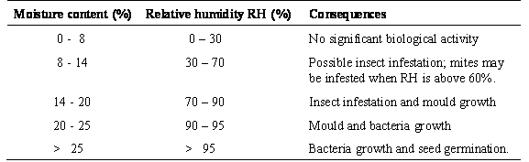
As a result of these consequences, there will be weight losses, quality losses and as a combined result of both losses there will be economic loss.

Raw Feedstuffs
(Pre-treatment)
Grinding
(Supplement addition)
Mixing
(Conditioning)
(Pelleting)
(Screening)
(Over-oiling)
Cooling
(Screening)
(Crumbling)
(Screening)
(Bagging)
Figure 2. Schematic presentation of Feed manufacturing process.

  - Drying or cooling techniques
- Generally, pelleted feeds emerge from the die at high temperatures and moisture contents
- They require cooling and/or drying.
- This is generally achieved by belt or drum dryers or simply by forced air convection in the final stage bulk storage hopper.

  - Storage/Sampling procedures
Storage is important aspect in fish feed. There are losses that can occur:
  - Weight loss
  - Quality loss (possibly even to the point of being harmful)
    - Nutrient loss (protein quality, lipid oxidation, vitamin loss)
    - heating/moisture effects
    - Flavour/palatability problems
    - Toxin production
  - Economic loss
- Factors involved:
  - Environmental (especially temperature & humidity)
  - Pests (insects, rodents, micro organisms)
  - Poor handling or poor quality control
- Preventative measures:
  - Check all incoming materials for damage/contamination
  - Store under clean/dry conditions out of direct sunlight
  - Avoid temp>20ºC if possible
  - Isolate/fumigate/destroy infested materials
  - Maintain high hygiene standards
  - Control rodents
  - Maintain good stock rotation
  - Store only materials <10% moisture
  - Keep stacks of sacks small and use vapour-proof multiwalled sacks or bins.
- Checks:
  - General appearance
    - Colour, texture, friability, smell
  - Evidence of ‘wetting’ (e.g. mould growth)
  - Presence of insects (esp. droppings)
  - Presence of rodents (esp. droppings)

  - Fish Feed manufacturing in Malawi, SADC region and beyond
One of the major problems encountered with the manufacture of pelleted aquaculture feeds within developing countries is that aquaculture feeds are invariably produced within feed mills specifically designed and geared for the manufacture of poultry and livestock feeds, and as such do not have the necessary capacity for fine grinding nor the material through - put to justify the purchase of such equipment. Needless to say the cost of fine grinding, both in terms of equipment procurement and energy consumption, is high Feed manufacturing in Malawi and the region is done mainly by Feed companies. These are either in livestock feeds in general or produce specific for fish.
Currently Malawi is producing feed through the MALDECO co in Mangochi and Protofeed in Blantyre. Both manufacturers produce sinking pellets. MALDECO is using their recently acquired feed mill from China. However, the production is done to supply to their fish cultured in cages.
At small scale, feed is produced by a number of government research institutions e.g. National aquaculture Center in Zomba, and the University, Bunda College of Agriculture.
In the SADC region, the South African production is dominated by a few large feed mills (42) producing approximately 4.4 million tonnes of animal feed per annum. With respect to aquafeed production, there are two major feed manufacturing companies that run aquafeed operations. Both operations produce in excess of 1 000 tonnes of feed per annum, and thus account for the majority of the country's aquafeed production. A number of smaller privately owned companies produce between 40 - 320 tonnes per annum. The high level of technical expertise and installed capacity suggests that there is sufficient capacity to produce the country's aquafeed requirements.
In contrast, Nigeria has the highest number of animal feed manufacturers (620), producing approximately 3.8 million tonnes of feed during 2000. The large number of feed mills can be attributed to the dominance of the sector by small-scale operators (59 percent of all feed mills produce between 0.5 - 5 tonnes/hour). Nevertheless, in 2000, the country's installed capacity was estimated at 7.25 million tonnes - this represents a production efficiency of only 52 percent. Thus, while only 10 760 tonnes of aquafeed were produced in 2000 (Figure 2), the gross underutilization of the feed milling capacity suggests that if there is sufficient demand, there is enough capacity installed to increase aquafeed production. A similar situation was reported from Zambia.
In comparison with Nigeria, the feed manufacturing industry in Zambia is much smaller, and is dominated by only three companies (accounting for 94.5 percent of the formal feed industry). Nevertheless, during 2000, two of the three major feed manufacturers reported operating at around 50 percent of capacity. Thus, an expanding Zambian aquafeed industry could potentially absorb some of the excess production capacity.
In 2000, animal feed production in Côte d'Ivoire and Kenya were 106 942 and 400 000 tonnes, respectively. Production capacity in these countries was restricted to eight manufacturers in Côte d'Ivoire, and over 30 millers and premix suppliers in Kenya. Unfortunately, there is no information pertaining to the production/utilization levels of these installations.
Table10. 6. Manufacturing capacity in the formal feed sectors (2000)
Country | Feed mills | Production(tonnes)
South Africa | 42ª | 4 474 558
Nigeria | 620^{b} | 3 800 025
Côte d'Ivoire | 8^{c} | 106 942
Kenya | 30+ | 400 000
Zambia | 3+ ^{d} | 79 000
^{a.} This figure represents the formal sector and represents approximately 60 percent of countries' total feed production.
^{b.} 440 private, 126 cooperatives, 54 publicly owned mills.
^{c} Eight manufacturers - the number of feed mills was unavailable.
^{d} Three major manufacturers produce 96 percent of the country's formal feed - the number of feed mills was unavailable.

10.8 Feed manufacturing in Europe
The information on European production is discussed here together with the Mediterranean context as most of the aquaculture production is happening in the Mediterranean area of the European side.
Mediterranean fish farming is focused on the intensive production of carnivorous fishes (i.e. trout, seabass and seabream), and formulated feed is the main production cost. Due to this growth in production the Mediterranean aquafeed market has grown by 58% in the 1995-2000 period (Fig 10. ). Parallel to these increases in production of aquafeed for marine fish there has been a substantial improvement in feed efficiency. Given the special environment of this developing business, aquafeed companies play an important role in the sector, not only by supplying fish feeds, but also by providing assistance through a wide range of services that are very difficult to find by other means. The challenges for the aquafeed industry in the Mediterranean are linked to the aquaculture sector itself and involve all issues threatening future development, among them the use of raw materials, the re-organization of aquafeed companies, and the adaptation to consumer and social demands.

Fig 10.3 Aquafeed markets in Mediterranean countries of main species intensively cultured.
Although the aquafeed sector in Europe and the Mediterranean is growing, it is estimated that it only accounts for 1% of the animal feed sector in Europe. Mediterranean aquafeed production is present in the main producing countries of carnivorous fishes. This industry can be described as a dynamic sector represented by about 25 feed companies, a significantly higher number of aquafeed companies than in northern Europe where about 6 feed companies operate in UK, Ireland, Norway, Iceland and the Faeroe Islands
In countries like France, Italy or Spain, main aquafeed companies belong to European group
leaders in the production of salmonid feeds, e.g. Biomar, Nutreco and Provimi. There are also
examples of local feed companies (e.g. Dibaq in Spain or Perseus in Greece); some integrated into aquaculture/agrofood groups, e.g. Feedus into Nireus Group (Greece) or Pinar Feed Industry and Marketing Co. into Pinar Group (Turkey). Few companies combine aquafeed production with the production of other animal compound feeds.

Although the average production of Mediterranean aquafeed factories is estimated to be slightly over 20,000 t, the production among different factories varies from 5,000 to 40,000 t or more. It is pointed out that in order to adapt to the new scenarios (i.e. production technology changes, growth of companies and the production capacity of their units, higher competition, etc.), the aquafeed companies should have a production of 30,000 t to cover the necessary investment and resources.

Table 10.7 Estimated aquafeed production in Mediterranean countries in 1995.

Aquafeed types and processing technology
The feed types and their processing technologies are summarized in Table 10.8.

Table 10.8 Present classification of commercial feeds
The selection of feed type is very variable and will depend to a large extent on the culture
conditions of each farm and on the consumer preferences in each country. Thus, feeds with 21-22% fat content are used for marine species and 26-30% for trout, although in some cases (i.e. France) a lower fat content is used. Furthermore, the selection of feed also follows a seasonal pattern, especially in marine fish.
The objective is not only to produce a feed that will achieve maximum growth and minimum feed conversion indexes, but also to address a whole series of factors aimed at obtaining physical characteristics of the feed so it will adapt to the farming systems of the different species, to seek a higher quality for the final product, and to cause minimum environmental impact through feeding. The production systems should also be able to guarantee the traceability and safety of the product at all times.

10.8.1 Challenges for the aquafeed industry in the region
10.8.1.1 Products and alternative raw materials
When compared to the needs for the production of other terrestrial animals, aquaculture uses only limited quantities of the raw materials that are available globally - only 1% of animal feeds in Europe are for aquaculture. Thus, there is no risk a priori for the supply of the basic raw material. However, due to various crises in the agro-food sector (fundamentally the mad cow disease and dioxins etc.) in recent years the feed companies have had to adapt to various restrictions in the use of raw materials such as the restriction in the use of animal meal or GM plant meals.

It is also necessary to evaluate the availability of natural resources, mainly fish meal and fish oil, which are nowadays indispensable for aquaculture manufactures, and compare the use made by aquaculture with other users (e.g. other animal sector) where it can be accessory. The demand for fish meal and fish oil, as major ingredients in aquafeeds, has steadily grown with the development of the aquaculture industry in the last decades. According to IFFO (International Fishmeal and Fishoil Organization) in the year 2002 aquaculture already used 34% and 56% of world fish meal and fish oil production, respectively. The prediction for the year 2010 is that aquaculture will use 48% and 79% of world fish meal and fish oil production, respectively. In spite of this increased demand, the world production of fish meal and fish oil remains more or less stable (about 6.5 million t of fish meal and 1.25 million t of fish oil), although with some serious fluctuations (up to 30%) due to phenomena such as "El Niño". This also raises concern about the uncertainty of future market vailability and prices.

10.8.1.2 Other challenges
The challenges for the aquafeed industry in the Mediterranean are linked to the aquaculture sector itself and involve all issues threatening future development, including the following:
(i) Re-organisation (concentration) of aquafeed companies: in order to increase production
efficiency, R&D optimisation, purchasing power, bargaining power with large customers, logistics.
(ii) Adaptation to the consumer and social demands: consumer demand of high quality products at low/affordable prices, concerns for healthy food, adaptation to ISO’s and HACCP quality certification and traceability throughout the whole production process.
(iii) Co-operation with fish farmers in common projects: to attend R&D projects together, based on common objectives such as fish quality and safe products for the market, use of drugs, environmental issues.

Learning Activities
* Visit to any manufacturing companies to learn how feed is processed and manufactured.
  - Storage of ingredients
  - Grinding and mixing of ingredients
  - Processing into marsh, pellets or crumbles
* Critique on selected journal articles on manufacturing of fish feed.

Summary to topic
Processing and manufacturing of fish feed is gaining ground in Malawi, the SADC region and the whole of Africa. This is due to development of aquaculture that needs feed as inputs. Fish feed are processed in different ways and done according to the need of the particular industry and fish species of interest. This is a technology that needs enhancement to produce better feed that can make fish grow faster and acceptable on the market.
The production of feed is done at small scale as well as a larger scale depending on the size of the industry. The feed is manufactured using various ingredients, mainly those that are locally available, and produced into marsh, pellets or crumbles.
The basic requirements for a good feed storage structure are that it should provide protection against high temperatures, humidity, moisture, insects and rodents. A common fault in the design of storage buildings is to neglect to provide for an adequately constructed floor. This, like the walls, should be effectively damp-proofed, and bags containing feeds should always be stored on wooden pallets.
Key indicators identified for the ability of countries in the sub-Saharan Africa to produce aquafeeds were existing livestock feed manufacturing capacity, availability of suitable feed ingredients for incorporation into aquafeeds, availability of suitably trained personnel, and favourable legislative and taxation system.
The European scenario has been discussed in the context of Mediterranean manufacturing situation. Issues of production, marketing, processing technologies indicate developing issues in feed manufacturing. A number of challenges faces have been highlighted.
Further Reading Materials
AAFCO (Association of American Feed Control Officials). 2000. 2000 Official Publication, Association of American Feed Control Officials Inc. West Lafayette, IN 47971 USA, 444p
Akiyama, D. & Hunter, B. 2000. A review of the Asian aquafeed industry, pp.36-38. International Aquafeed Directory & Buyers Guide 2001. Turret RAI plc, Uxbridge, UK.
Barlow, S.M. (2002). The world market overview of fish meal and fish oil. Paper presented at the 2nd Seafood By-Products Conference, Alaska, November 2002. Available at the IFFO (International Fishmeal and Fishoil Organization) internet site: http://www.iffo.org.uk/tech/alask htm.
De Silva, S. S. and Anderson, T.A. (1995). Fish Nutrition in Aquaculture, Chapman and Hall. London.
Fernández, A. Alvarez, E. and Basurco, B. 2003. Aquafeed production in the Mediterranean region.ProAqua Nutrición S.A., Apdo. de Correos 16, Ctra. N-620, Km 99, 34210 Dueñas, Palencia, Spain. Cahiers Options Méditerranéennes, Volume 63:113-119.
Hardy R. W. and F. T. Barrows. 2002. Diet formulation and manufacture. Pp. 505-600. In: Fish Nutrition. 3rd Ed. Elsevier Science. New York, USA.
Jauncey, K. 2006. Nutrition foundation modules. Postgraduate program. University of Stirling, Scotland, UK.
Moehl, J. and Halwart, M. (eds) 2005. A Synthesis of the Formulated Animal and Aquafeed Industry in Sub-Saharan Africa. CIFA Occasional Paper No. 26. Food and Agriculture Organization of the United Nations, Rome. 61p.
New, M.B., Tacon, A.G.J. & Csavas, I. 1995. Farm-made aquafeeds. FAO Fisheries Technical Paper No. 343.

Useful links
http://www.aafco.org
http://www.afia.org
http://www.fao.org/docrep/003/X8576M/X8576M00.htm
http://www.fao.org/agrippa/publications/ToC3.htm
http://www.fao.org/docrep/008/a0042e/a0042e00.htm#Contents
http://www.fao.org/docrep/003/V4430E/V4430E00.htm#TOC
http://www.aquamedia.org/production/feeds/sabautcipa_en.asp.
http://www.fao.org/fi/statist/statist.asp

